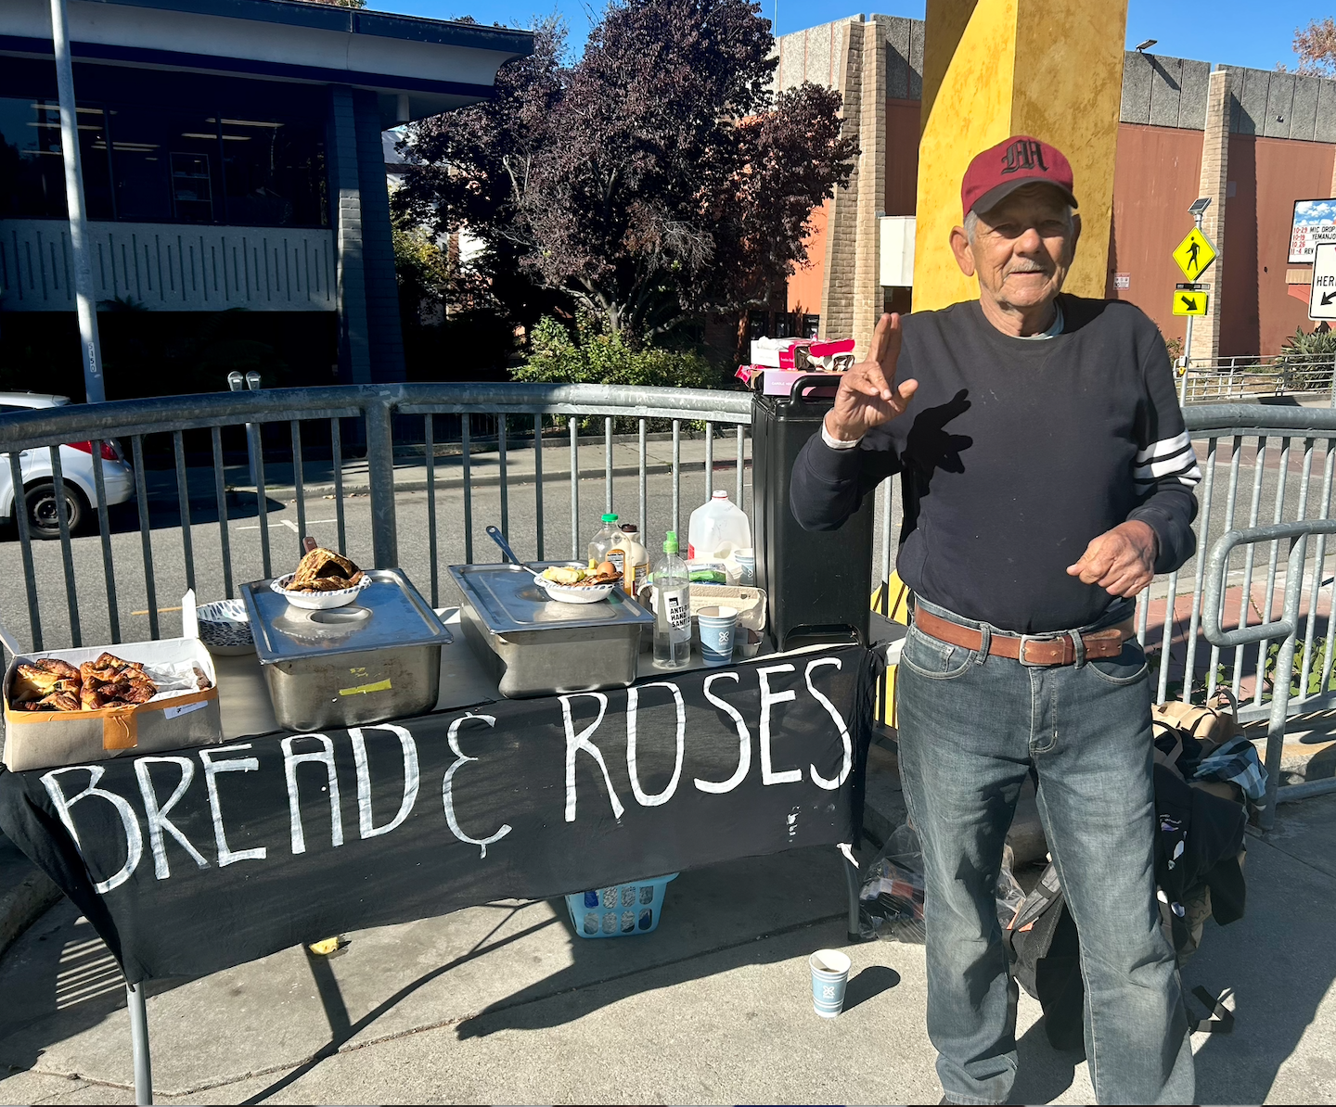
Recently, I met with Susan Crane, a good friend and 80-year-old peace activist, before she left to start a 229-day prison sentence in Germany. Susan is part of an international peace group protesting the proliferation of nuclear weapons, specifically the United States’ practice of holding nuclear weapons around the world. The United States stores B61 H bombs in Belgium, Turkey, the Netherlands, Italy and Germany. Since 1996, 64 German peace organizations have organized a yearly peace camp outside the Büchel Airforce base, and invited US American war resisters to join them in demonstrating against the U.S. B61 H bombs held there. Susan received her prison sentence for nonviolent civil disobedience at the Büchel in Germany last year. This month, she and other war resisters make a pilgrimage on foot from Büchel Air Base where the US nuclear weapons are held to the prison where she’ll begin her sentence.
Susan’s daily life at the Redwood City Catholic Worker house is much like the work we do at Bread & Roses: feeding hungry people, organizing resources and support for the outcast, and finding common dignity in meeting people’s basic needs. Susan and I stood in her bedroom over the banner reading “Swords to Plowshares: Ceasefire Now” that she painted to carry on her pilgrimage. She remarks, “[Nuclear weapons] imprison our imagination and take the money we need for a myriad of projects. They are a theft from the poor… from all of us”.
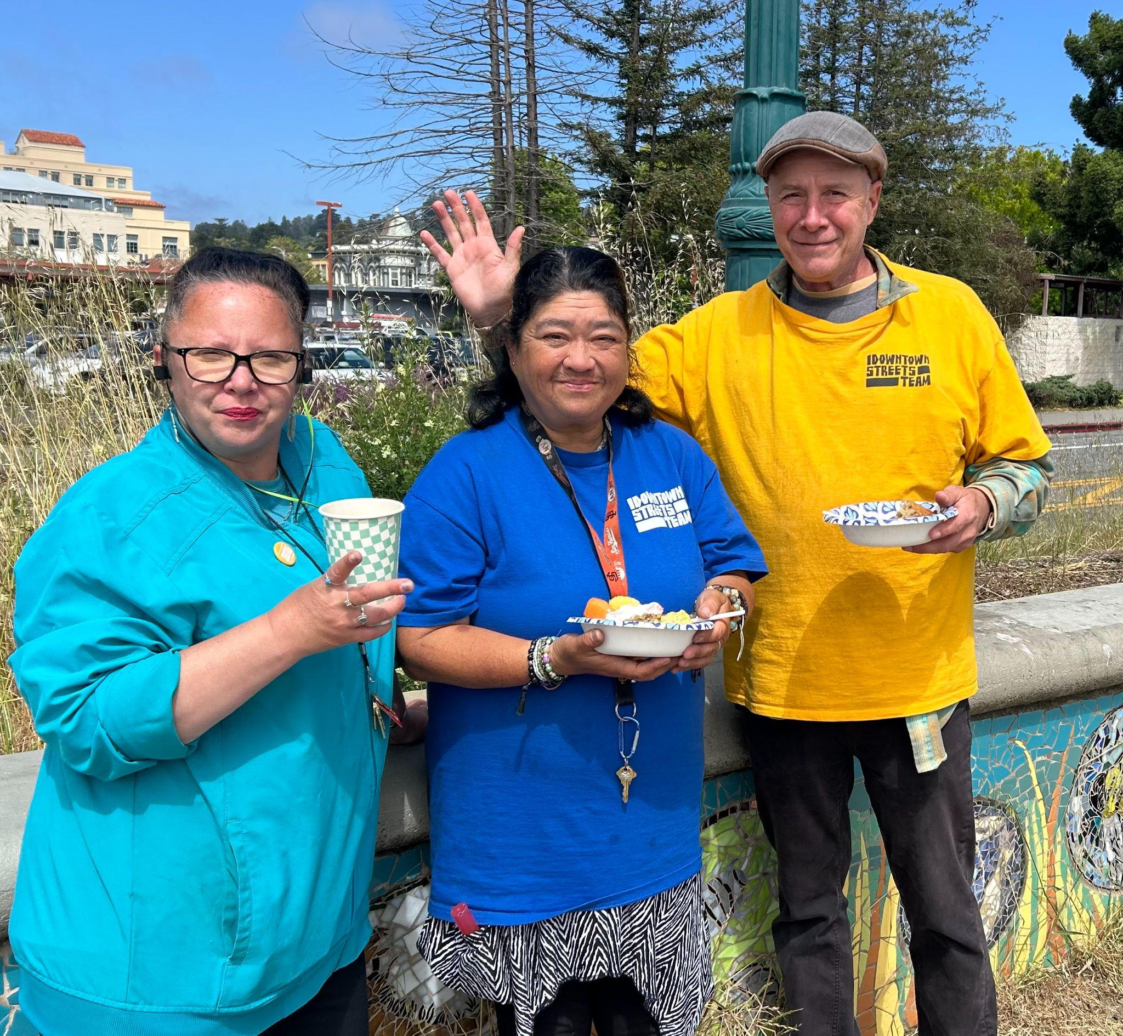
The United States’ warmaking abroad in many ways causes our systemic and prolific poverty domestically. The US’ facilitation of Palestinian genocide prevents funding and prioritization for housing, healthcare, and education domestically. With militaristic police presence on US streets, focus shifts away from the underlying needs of people in distress, and towards criminalization. Within Bread & Roses, our commitment to feed and clothe our siblings locally is our protest to the country’s unfettered militarism. Tending to the wounds of poverty locally is our prayer for the embracing of peace abroad. In Susan’s words, “We hope that others will think that what we’re doing makes sense and join us, or do what they can in their own way to move us toward a more peaceful world”.
With love, Calia and the Bread and Roses team

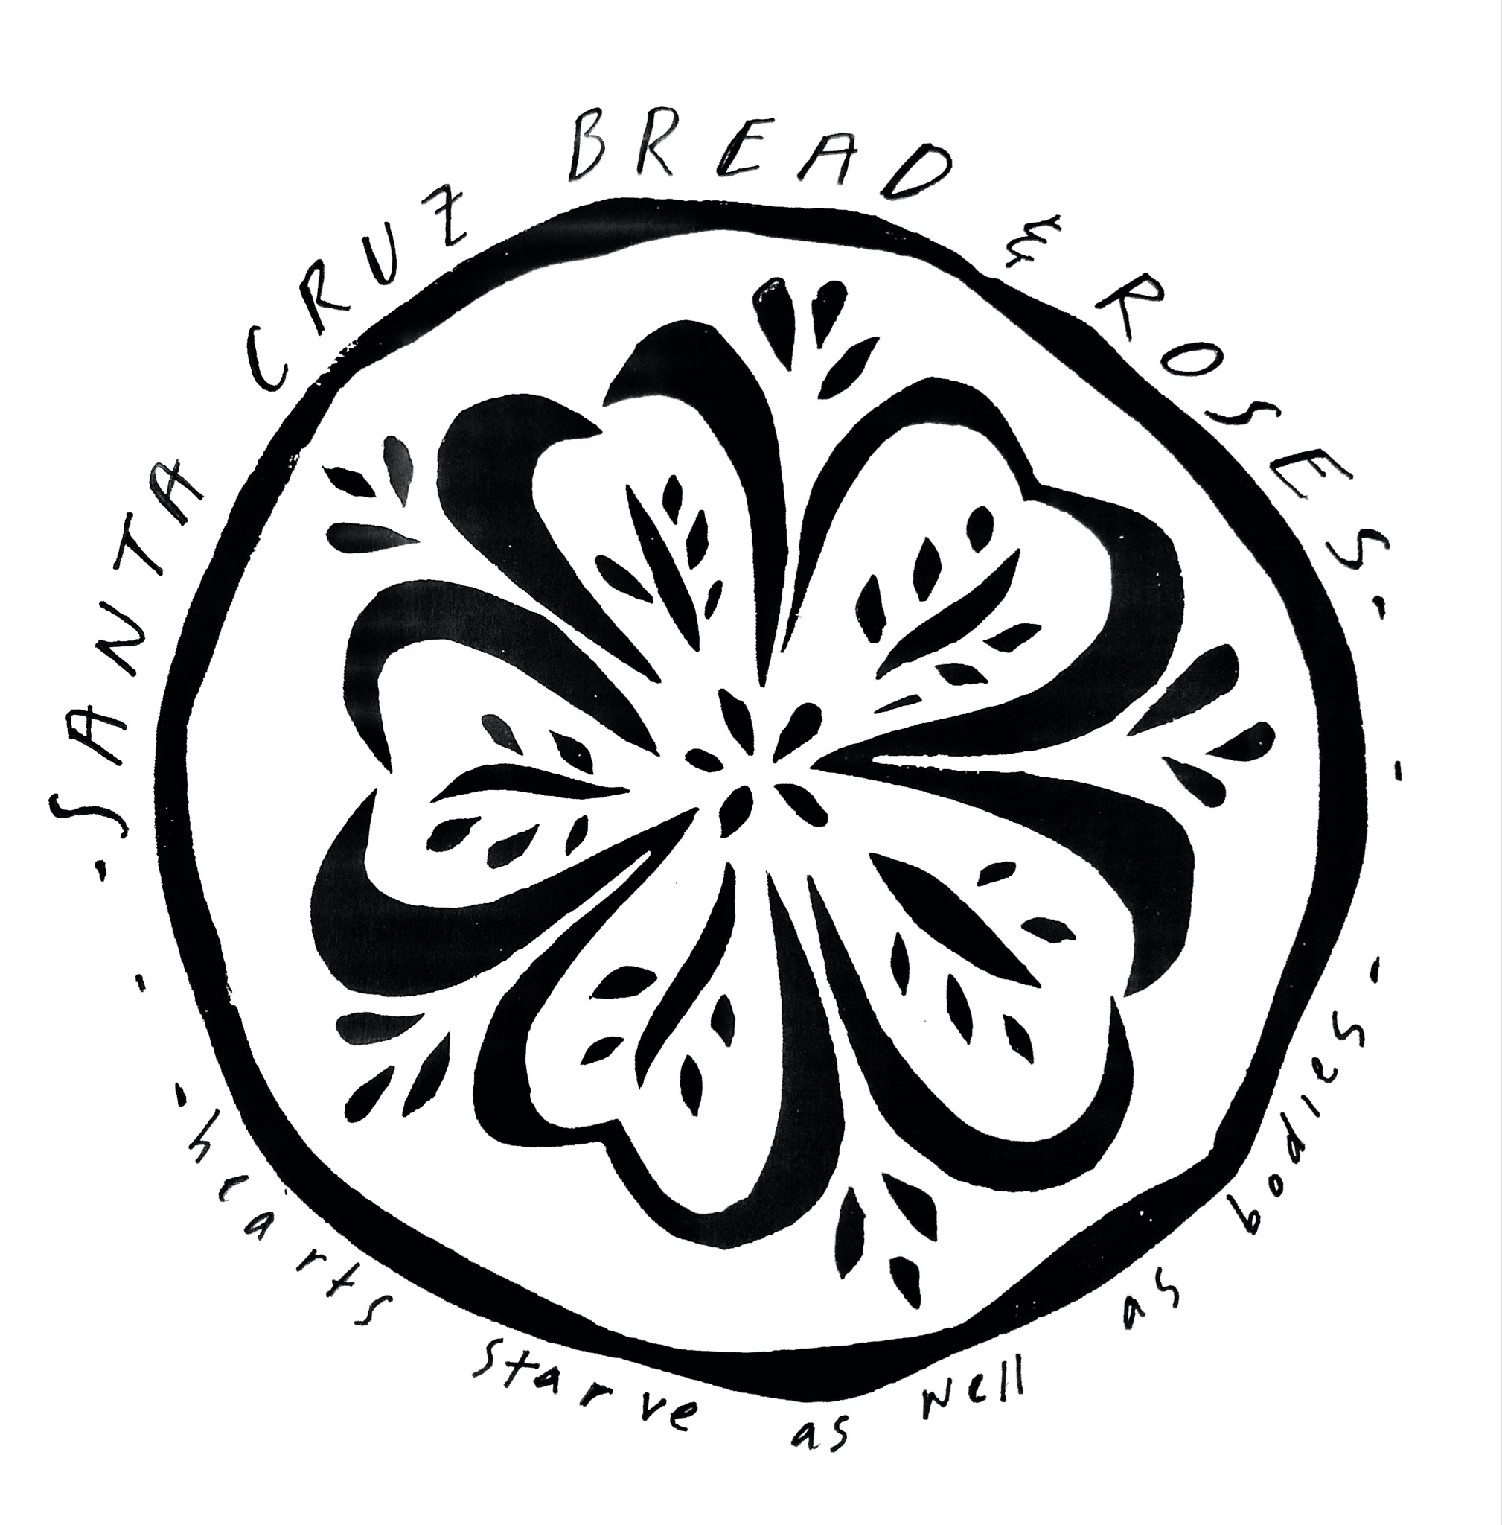

Santa Cruz Bread and Roses accompanies those experiencing homelessness and poverty in Santa Cruz by nourishing people’s basic physical needs with joy and dignity.
We serve breakfast and essential supplies for free on
local streets 3 times weekly.

Check it out!
- Summer potlucks: Join us for two connected gatherings on peacemaking in our present time. On July 6th, we’ll reflect on brief writings with an eye on what moves, troubles, or inspires us. Then on July 20th, we’ll gather with other inspired writings about peace and consider what we can do in coming months (with a divisive election fast approaching) to act as peacemakers. We’ll provide a simple meal; please RSVP if you can. 5pm at 1319 Laurel St. Santa Cruz.
- Are you part of a community or faith group interested in learning about the history of the Catholic Worker or our vision of the coming Bread and Roses Cafe? Let us know if you’d like to host us for an informative discussion!
Can you make a monthly financial donation? Contribute to our current work and help fund the future Bread & Roses Cafe, a hub providing nourishing food on a sliding-scale payment model, basic supplies, and a sense of belonging for all.
Mail a check or use the link below: PO Box 2142 Santa Cruz CA 95063

