“Could I take two more plates to-go, please? There’s a woman and her son who live in their car near me and I want to make sure they get some good food.”
Rick encountered Bread & Roses by chance while riding by one morning while we served. Now he is a consistent presence alongside and helps us set up supplies regularly. Sometimes Rick has already eaten by the time we serve, but comes by anyways to see what we’ve cooked and to enjoy the company. A scruffy beard can’t hide his soft smile, and his trouble hearing doesn’t keep him from engaging in friendship with all who stop to join us. Rick brings an extra plastic bag just to package up extra bowls of food to take to people living in their cars or who can’t make it to our distribution.
Another man stopping by our distribution table recently said, “This makes the town feel a little less forsaken.” Rick’s thoughtfulness and steady presence on our distribution days reminds us of the potential we all have for companionship, especially in areas that most of society deems untouchable. He brings his gifts of kindness, and they meld beautifully with what each of us brings to the table as well.

We’re so grateful for your partnership with us in the development of Bread and Roses this year.
Would you consider becoming a monthly donor to help us continue this joyful work?
Financial donations may be made online or by mail at the address below.
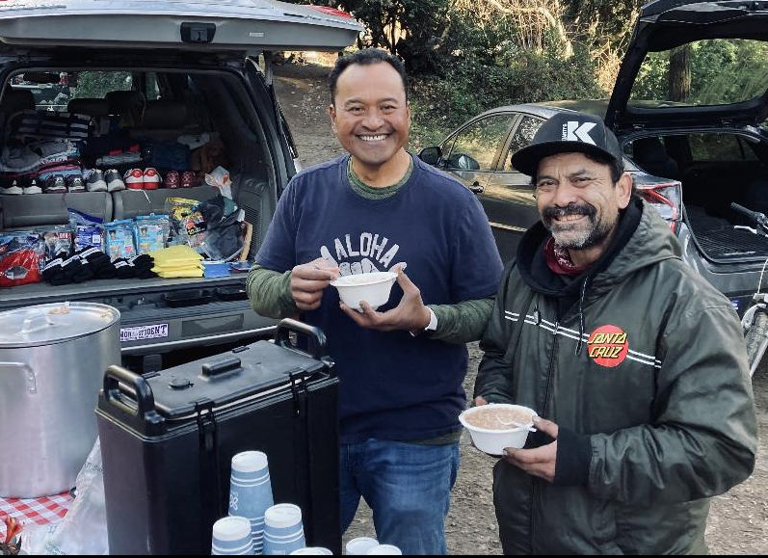
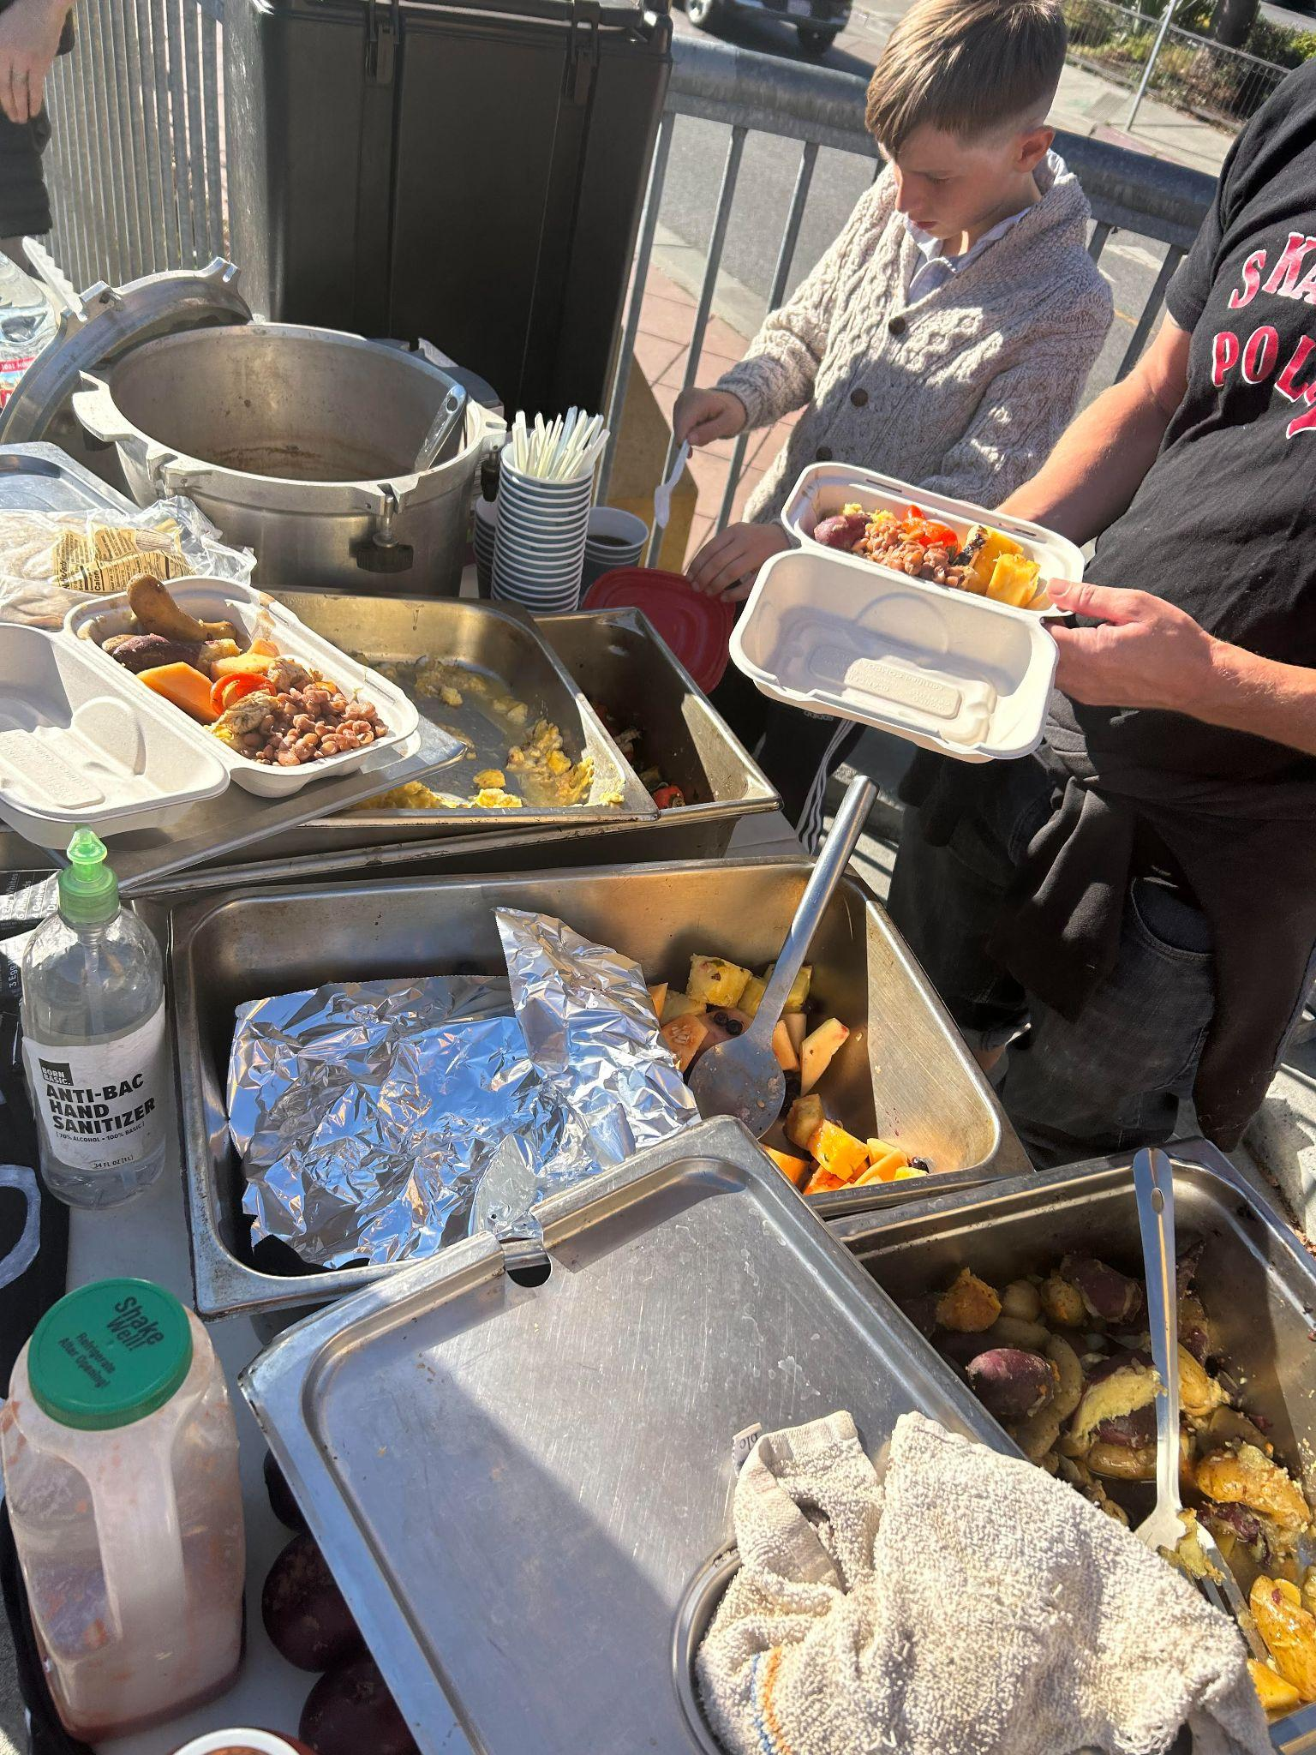
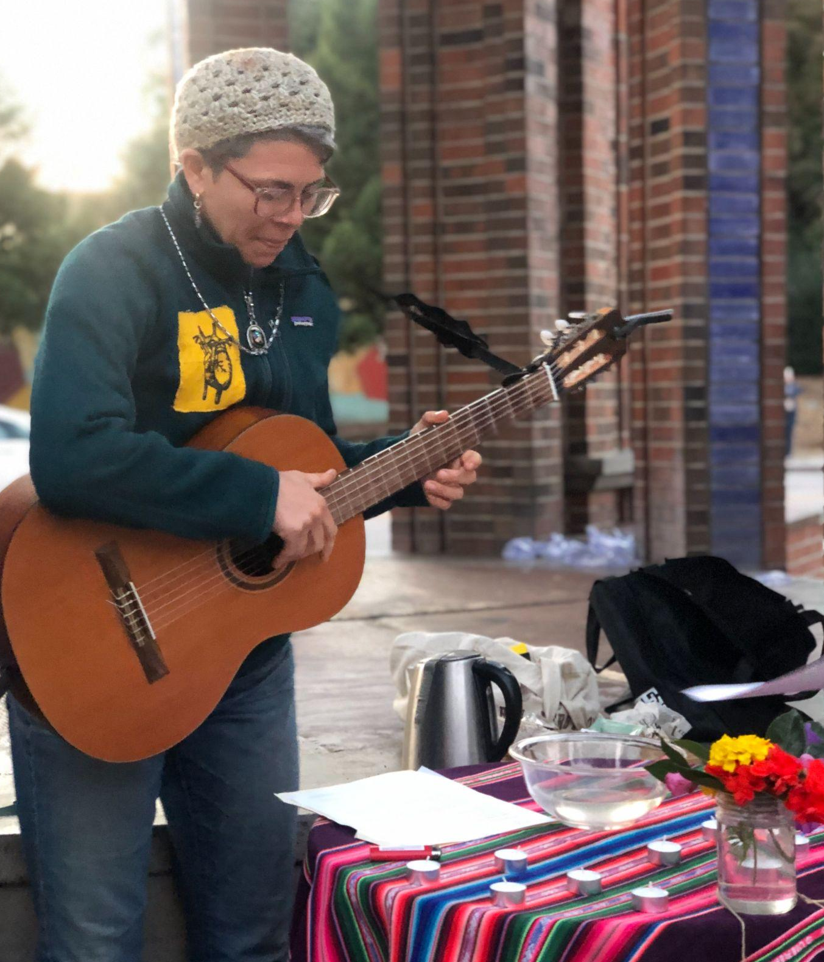

New friends sharing breakfast and supplies

Fall Liturgy honoring those who
passed away on the streets this year
Get Involved!
- 20th Annual New Year’s Vigil for Peace- Join with a variety of faith and community groups to gather in peace and hope for the new year. The evening is co-hosted by Bread & Roses to benefit our ministries! December 31, 7:30-9:30pm. Holy Cross Parish (Main Hall) in Santa Cruz
- We’re in need of clean jackets, pants, shirts, shoes, and blankets for winter distributions. Ask your friends and neighbors if they’ve got some to donate as well! 😊



Santa Cruz Bread and Roses accompanies and supports those experiencing homelessness and poverty in Santa Cruz by nourishing people’s basic physical needs with joy and dignity.
We serve breakfast and essential supplies for free on local streets 3 times weekly.

Save the date!
20th Annual New Year’s Vigil for Peace: Join with a variety of faith and community groups to gather in peace and hope for the new year. The evening is co-hosted by Bread & Roses to benefit our ministries. December 31, 7:30-9:30pm. Holy Cross Parish (Main Hall) in Santa Cruz

Can you make a one-time or monthly financial donation? Contribute to our current work and help fund the future Bread & Roses Cafe, a hub providing good food on a sliding-scale payment model, basic supplies, and a sense of beauty and belonging for all.
Mail a check or use the link below: 1319 Laurel Street, Santa Cruz CA 95060

