October 2022
Santa Cruz Bread & Roses

The poor have a right to bread, but we have the right to roses too.
I see it in the dusty, blue tarp and tent-cluttered encampment by the river, where Greg plants tomato, sunflower and squash from seed, later sharing the bounty with neighbors on a sunny Tuesday morning.

We work for bread, but we work for roses too.
After a night of September rain, campmates pull apart sopping blankets and lift fallen elm branches; gathering around a smoldering fire pit, they strum folk tunes and lead neighbors in song.

The worker has a right to bread, but she has a right to roses too.
In the encampment as we serve breakfast, Trey limps out of his tent to contribute two jars of peanut butter and coffee creamer to our wagon. Thanks to him we're able to offer the dignity that comes with such touches of beauty, of the power to choose, of unexpected delight.
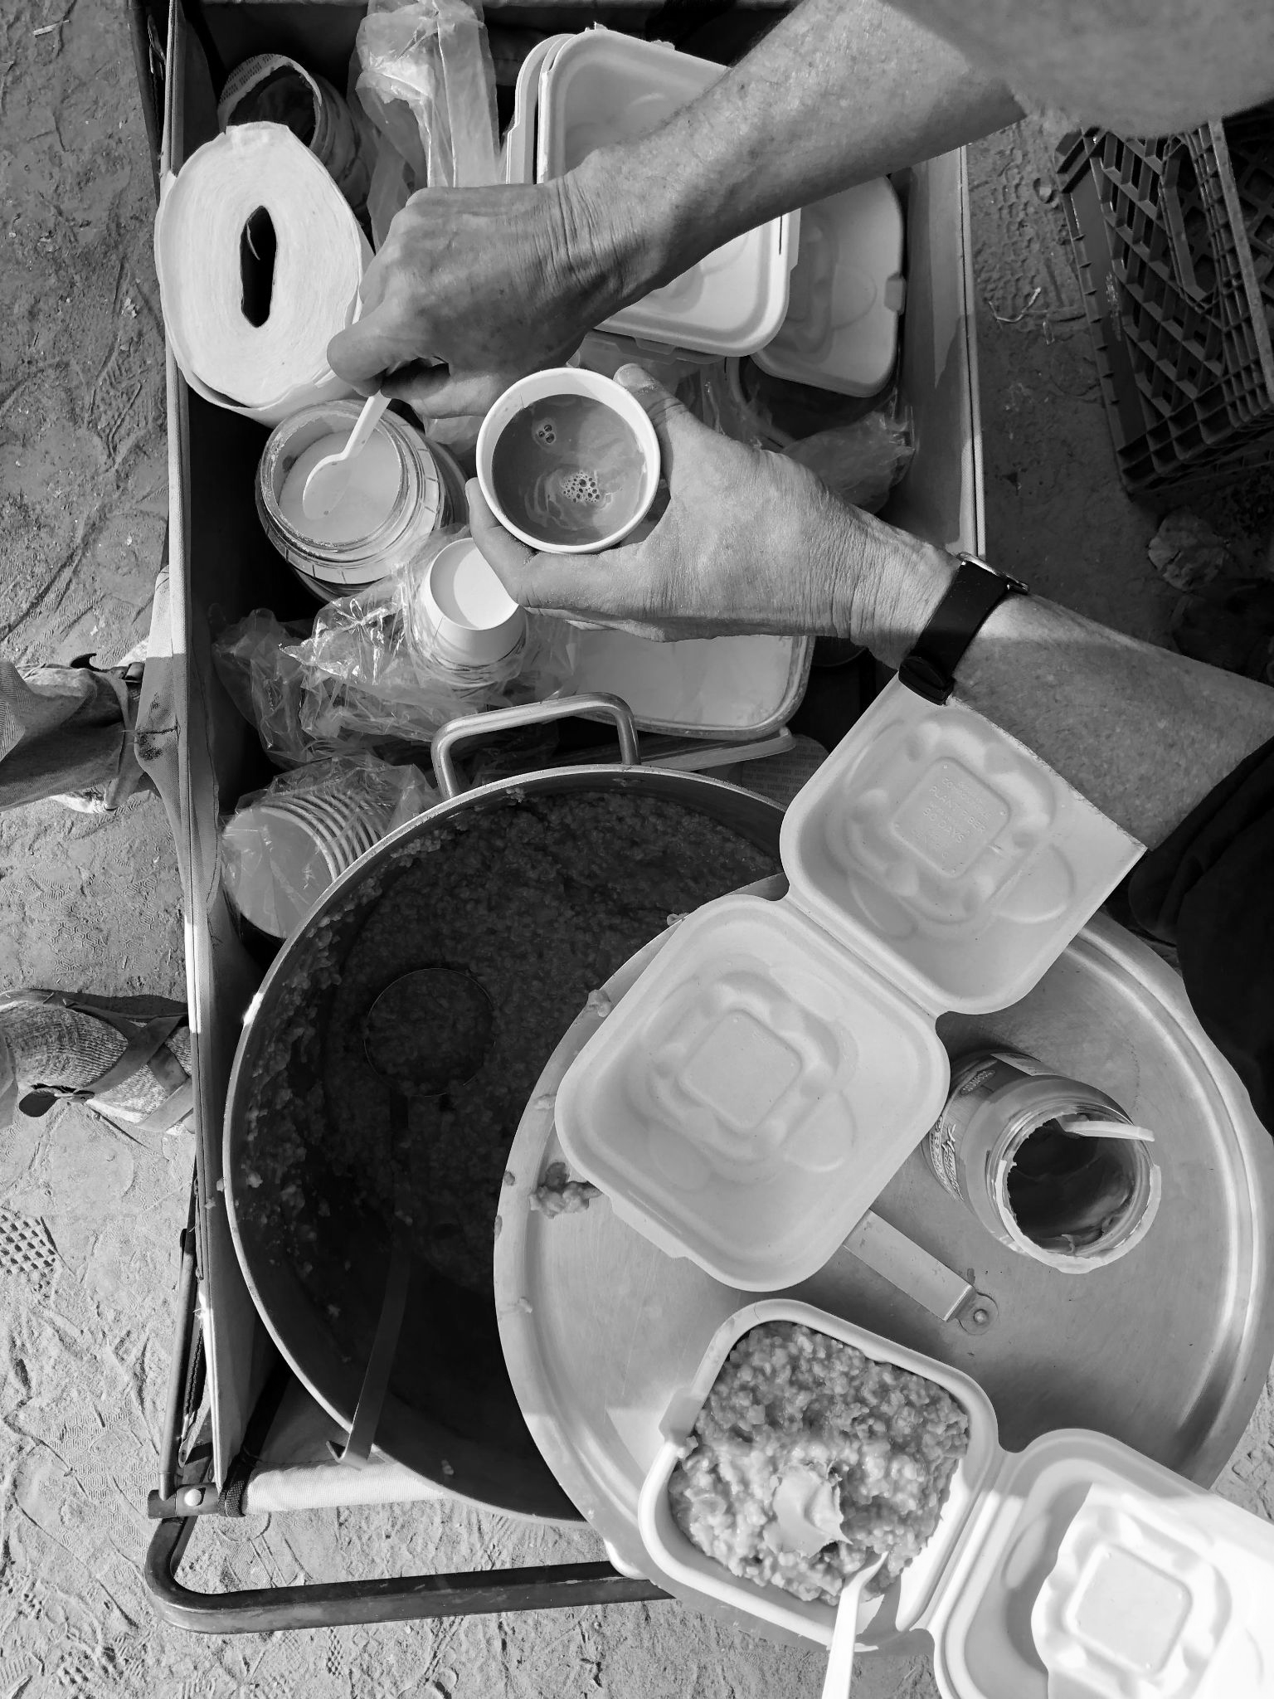
We envision a world where, yes, all are sheltered, fed, and medically covered, and also where rest, creativity, and joy are prioritized. The internal hunger to thrive and not merely survive, is part of what makes us human. And the vision we have for the world is one we must build first in our own dwelling places.
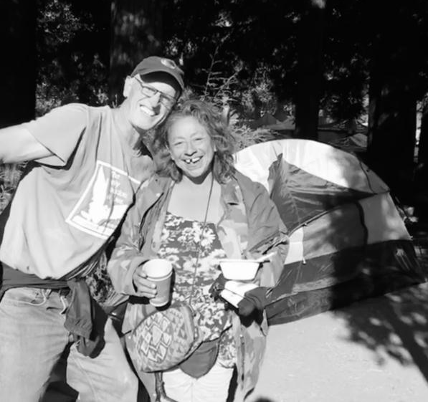
Here we organize our lives around meeting the direct needs of the oppressed, and how we do so is just as important: with kindness, honor, and joy towards one another.

We are building SCBR to be a breathing example that community is possible across class and background, that joy is possible even as we wake to the world's wounds, that beauty is present even in the muck of capitalist oppression.
Join us in working for bread, and in working for roses too.

To support our current ministries to people experiencing homelessness, and to fund a space where we can expand these supportive services, donate online or by mail:
www.scbreadandroses.org ~ IG & FB @scbreadandroses


This month, we continue serving breakfast in the main homeless encampment, helping displaced neighbors move, putting together care packages for folks released from county jail. We are fundraising to buy a space to expand ministries.
~
Can you lend a hand? We can use the following donations:
- Rain gear and warm clothing for people displaced from encampments
- Peanut butter and nonperishable food
- Hygiene items and new underwear for people recently released from jail
- Financial donations for the Bread & Roses location, a cafe-like setting where people can come for basic supplies, a sense of beauty and belonging.

