❈

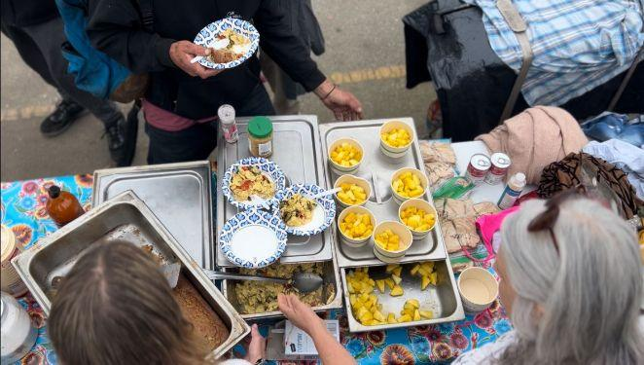

Santa Cruz Bread and Roses accompanies those experiencing homelessness and poverty in Santa Cruz by nourishing people’s basic physical needs with joy and dignity.
We serve breakfast and essential supplies for free on
local streets 4 days weekly.

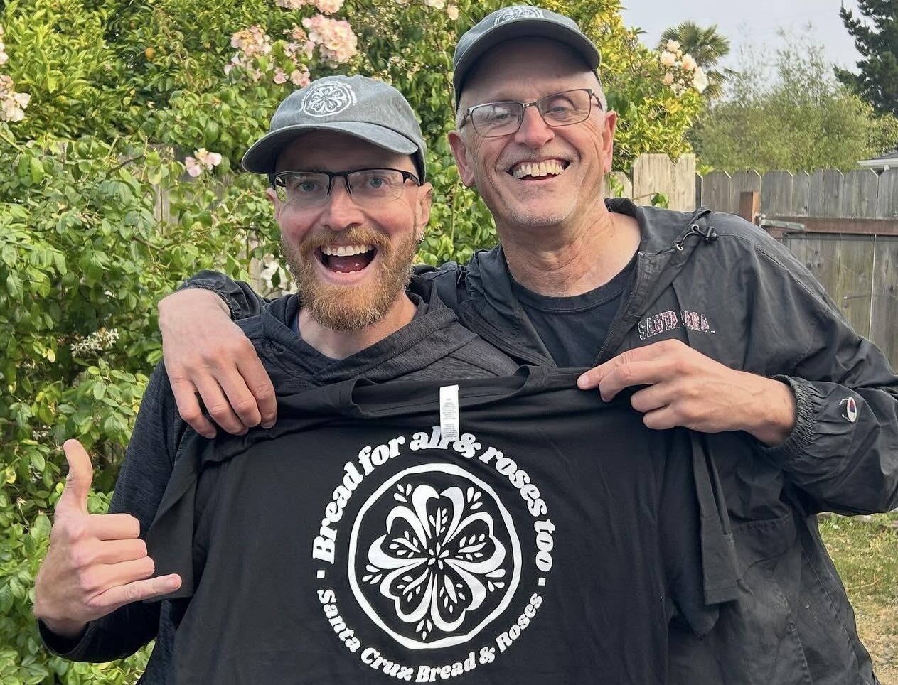

- Fall Fundraiser: Oct 4th, 5pm - SC Bible Church
- We still have SCBR sweatshirts, hats, and shirts! All proceeds go straight to our work on the streets. Visit us online or email us for sizing info and to order.
- Do you have adult clothing or hotel-sized hygiene supplies to pass along? Contact us to coordinate a drop-off or pickup.

