This month’s reflection comes from Meg Milligan, a senior English major at Santa Clara University who has been regularly volunteering for one of our weekly meal shares.
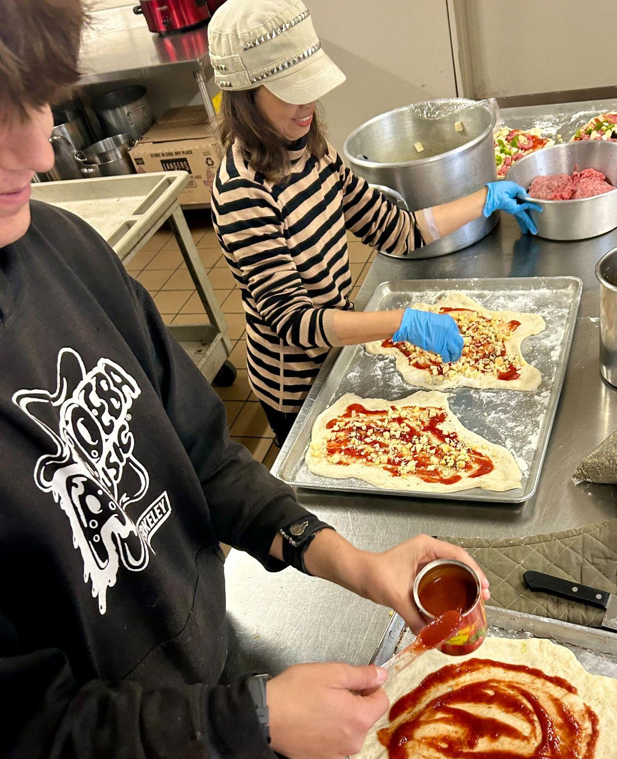
My solo drives along the windy roads of Highway 17 to Santa Cruz are ones I anticipate every Sunday morning. In my thirty minutes of reflection every week in my car, many thoughts run through my mind, but the glimmer of hope over the hill in Santa Cruz keeps me moving. I find myself thinking about the endless lessons I have learned working with Santa Cruz Bread and Roses before picking up a former Los Angeles Catholic Worker intern. From seeing the smiling faces skate, bike, or walk up to our table to petting dogs that peek their noses under the table, the moments shared are ones I hold close to my heart. If you had told me years ago that I would spend each Sunday morning of my senior year of college serving oatmeal and coffee in Santa Cruz, I would have never believed you. Despite growing up in the Bay Area my whole life, it was not until two years ago that I began to feel an immense sense of helplessness towards the issue of homelessness. It was then that the Catholic Worker Movement came into my life: bringing me to Santa Cruz Bread and Roses.
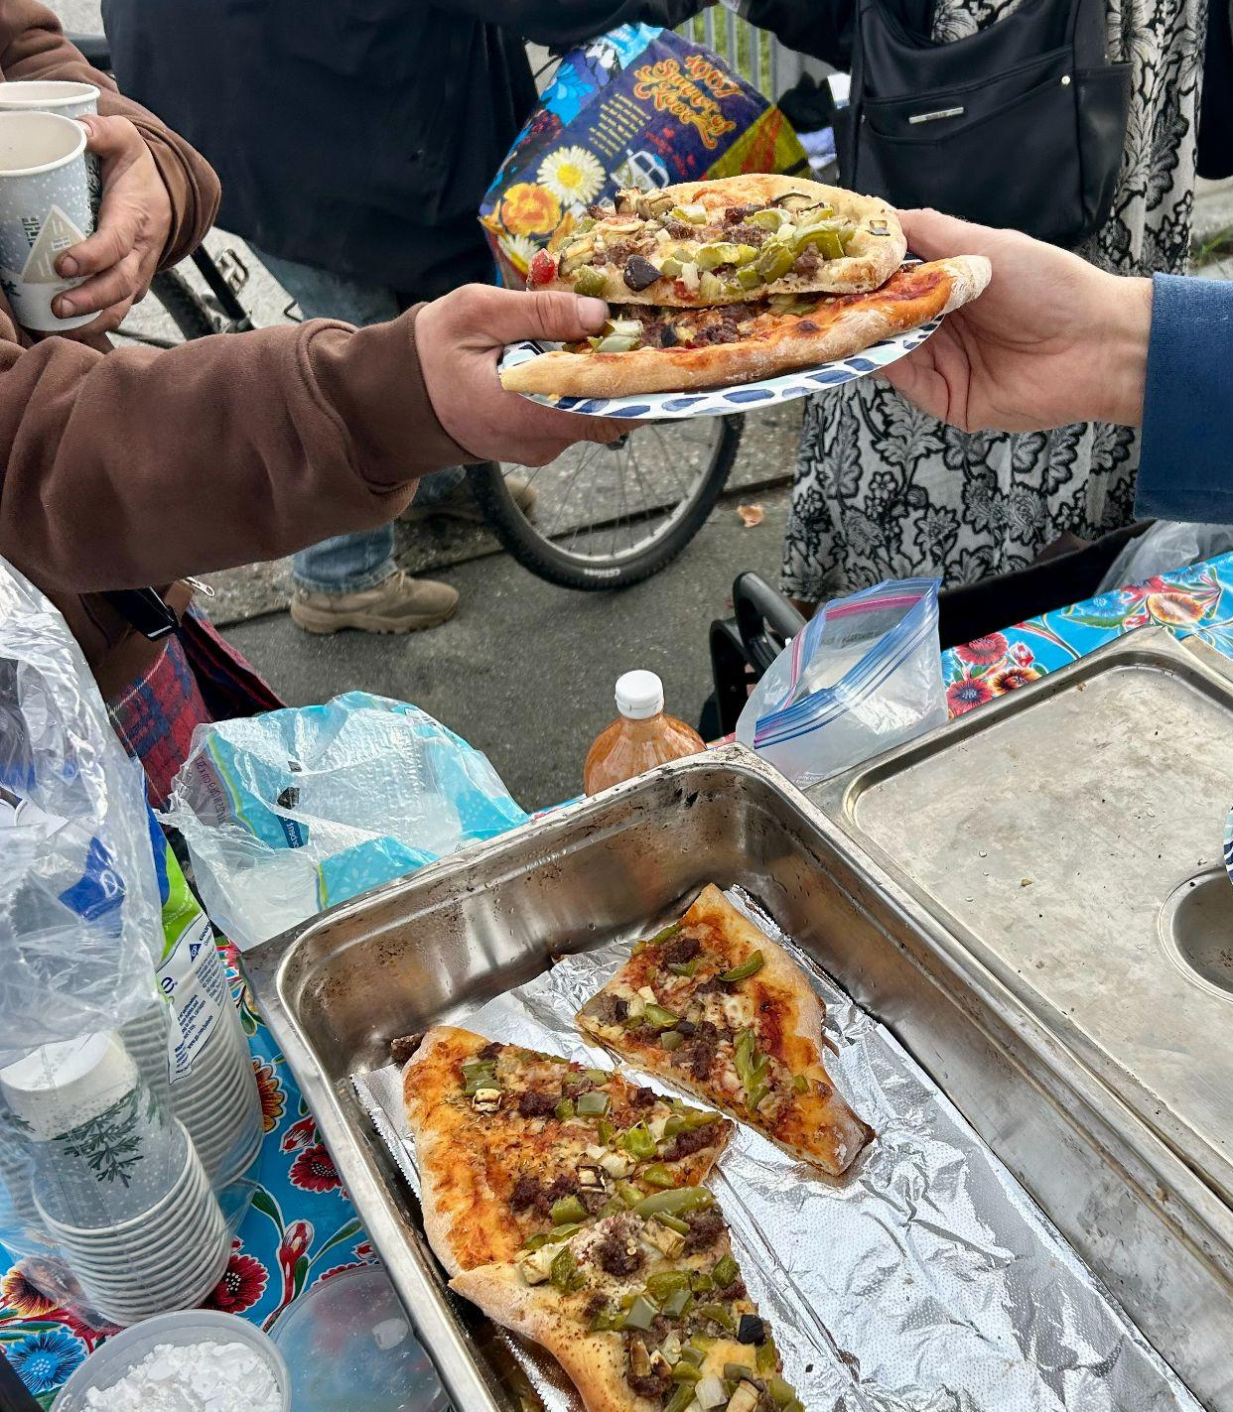
For the past three months, I have devoted each Sunday to spending my time with folks who lead me to dig deeper into my mind every week. A story that has stuck with me is that of a man who came to America from Jamaica and continually shares his love for music with us. Every Sunday since meeting this man he has sat and waited for us to arrive with our cart, table, and smiling faces. He shares his smile and stories with us every week, slowly opening himself up to us more and more. It is beautiful to share these little moments with people who are so often overlooked, but Bread and Roses goes above and beyond. They not only provide food for those who need it but their time and devotion, which I will always cherish. The paths that cross when standing with oatmeal and coffee will continue to pass through my mind each time I drive over the hill of Highway 17 each Sunday.
~ Meg Milligan
Can you help? We are hoping to start a *fourth* day of meal service in January, and are looking for someone with a car to help transport food from our kitchen to downtown for meal service. Please let us know if you are interested in helping with driving, cooking, or serving.


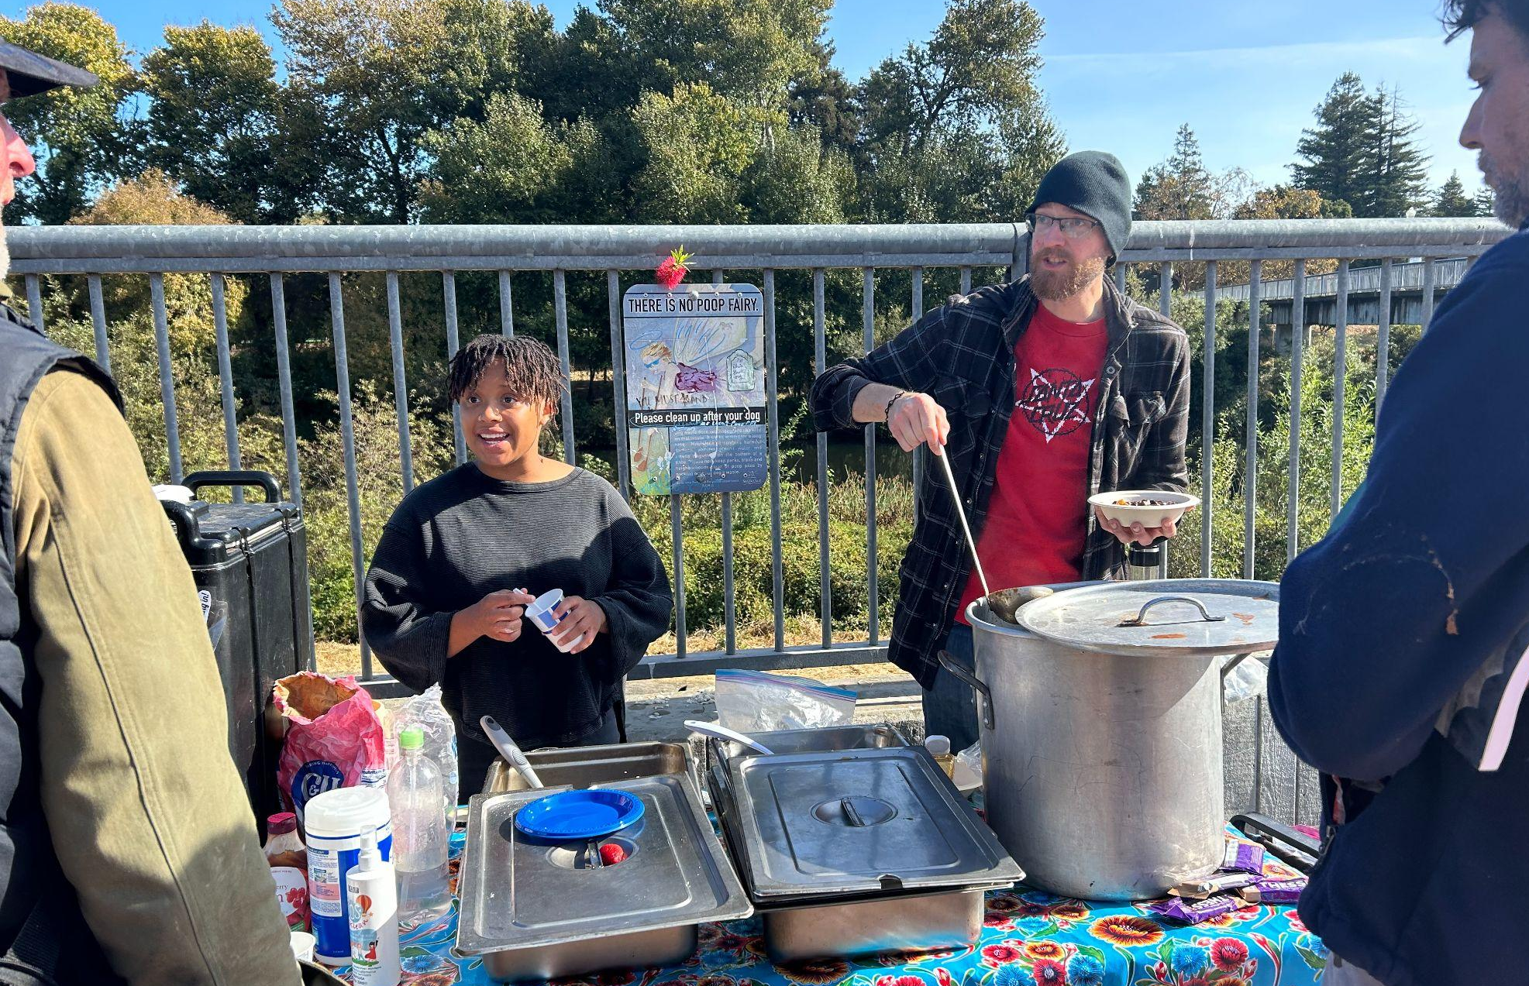

Santa Cruz Bread and Roses accompanies those experiencing homelessness and poverty in Santa Cruz by nourishing people’s basic physical needs with joy and dignity.
We serve breakfast and essential supplies for free on
local streets 3 times weekly.

- Do you have old clothes or blankets? We can get them to people who need them! Let us know if you have donations of nonperishable food, hygiene supplies, or clothing to pass on.
- Can you make a monthly financial donation? Contribute to our current work and help fund the future Bread & Roses Cafe, a hub providing nourishing food on a sliding-scale payment model, basic supplies, and a sense of belonging for all.
Mail a check or use the link below: PO Box 2142 Santa Cruz CA 95063

