This month’s reflection comes from Matthew Fina, an English major at UCSC, who regularly volunteers at one of our weekly meal shares.
When asked why I go out and serve with SCBR I first thought of good reasons: empathy, love, the belief that no one should be allowed to go hungry, and then shortly after found a slew of lesser ones: guilt, pity, and self-loathing hidden in amiability. I thought back to the first time I served downtown and what emotions held me then. In my thought a singular sentiment arose right away: a totaling and uncompromising fear.
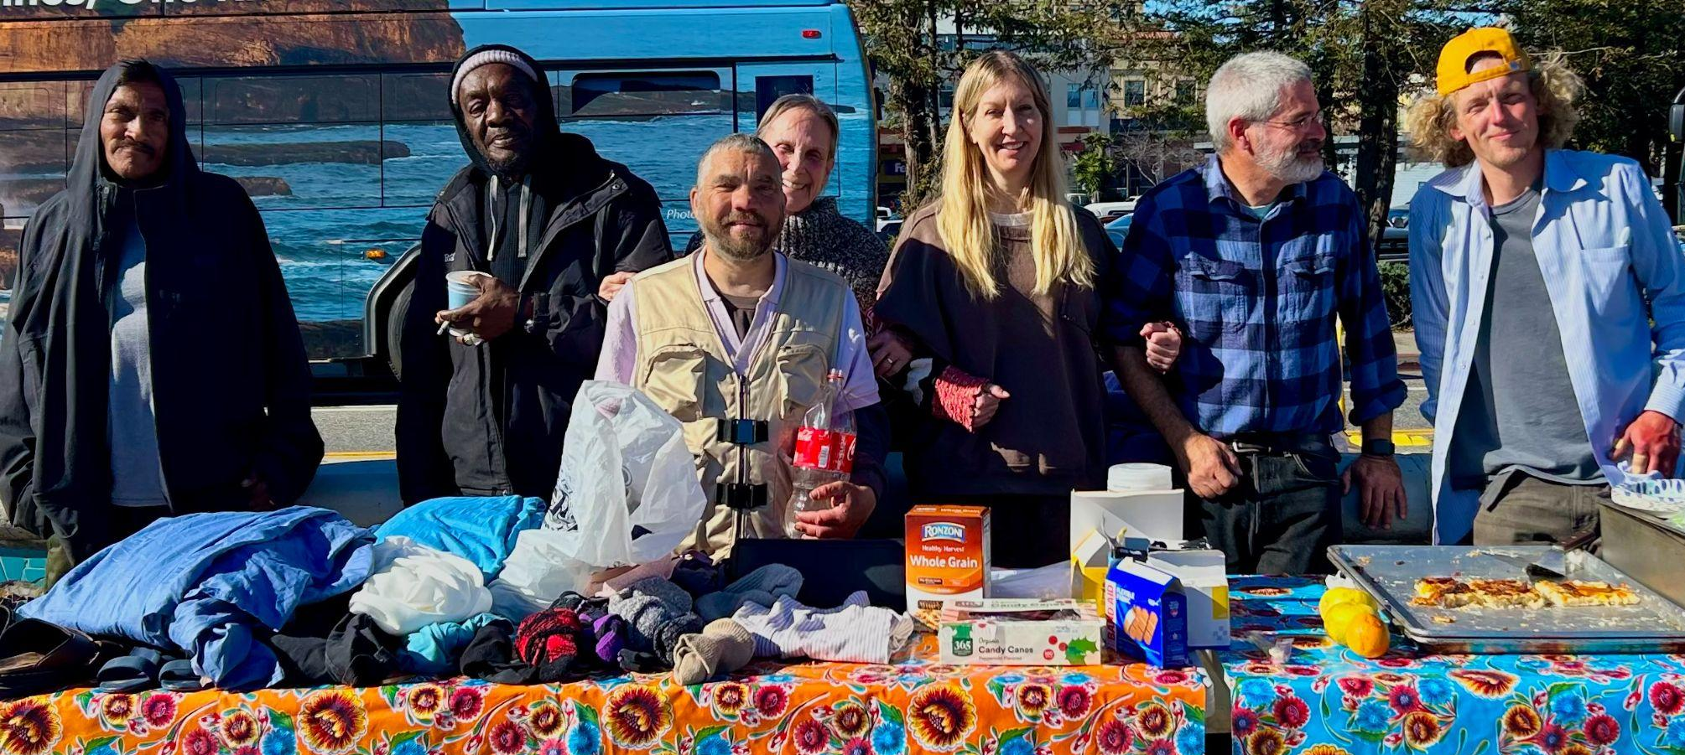
I’m certain the fear had something to do with the crippling poverty and malaise which had cropped up in the streets around me, scenes that contrasted so violently with my quiet suburban upbringing. The feeling was furthered by a new image which had begun to take shape in my mind. I saw an older version of myself standing in those same streets, but somehow I understood he was no longer an outsider, that he had become mired into that disastrous foreign world. Long ago I had assured myself that wealth could be lost, that minds are susceptible to failings and illness, and that through rashness or stupidity I could somehow remove myself from a presupposed comfort.
As I kept returning each Sunday, I realized these fears guarded against a deeper, inevitable truth. I discovered I was slowly becoming less worried about my life intersecting with the people I met on the street, and more afraid that it wouldn’t, or more, that it couldn’t. That my life was inevitably slated to be this way, and their life was slated to be another. What I was afraid of concerned the reasons behind why a man, who looked only a few years older than myself, had spent the few hours before our morning meeting frantically trying to awake his wife from a drug-induced slumber on the cushions of his car which was really a house, while I, seated in a university apartment, had leisurely engaged in a series of unprolific daydreams over peanut butter toast and coffee.
I serve oatmeal and coffee on Sunday mornings because it gives me hope. It allows for me to inhibit the belief that this rift between people who have and those who have-not is ultimately a choice. A choice which can be refuted and redeemed through the hard work of those who decide to look down instead of up, of those who notice everything they have to give instead of everything they have to gain. I hope this way of seeing and being continues to grow and that one day, upon arriving at my morning coffee ritual, I fill only two cups. One for a stranger and another for myself seated beside them. ❈

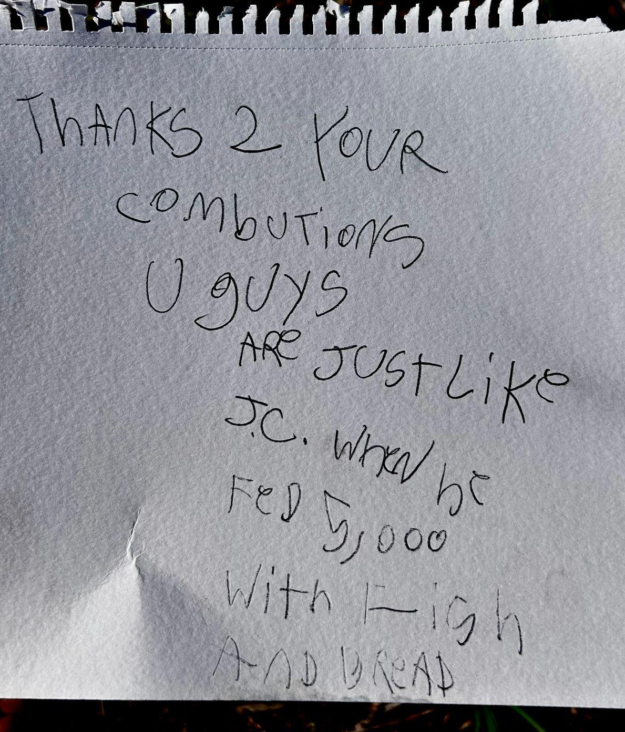

Santa Cruz Bread and Roses accompanies those experiencing homelessness and poverty in Santa Cruz by nourishing people’s basic physical needs with joy and dignity.
We serve breakfast and essential supplies for free on
local streets 4 days weekly.

← A recent note left for SCBR by a new lunch guest

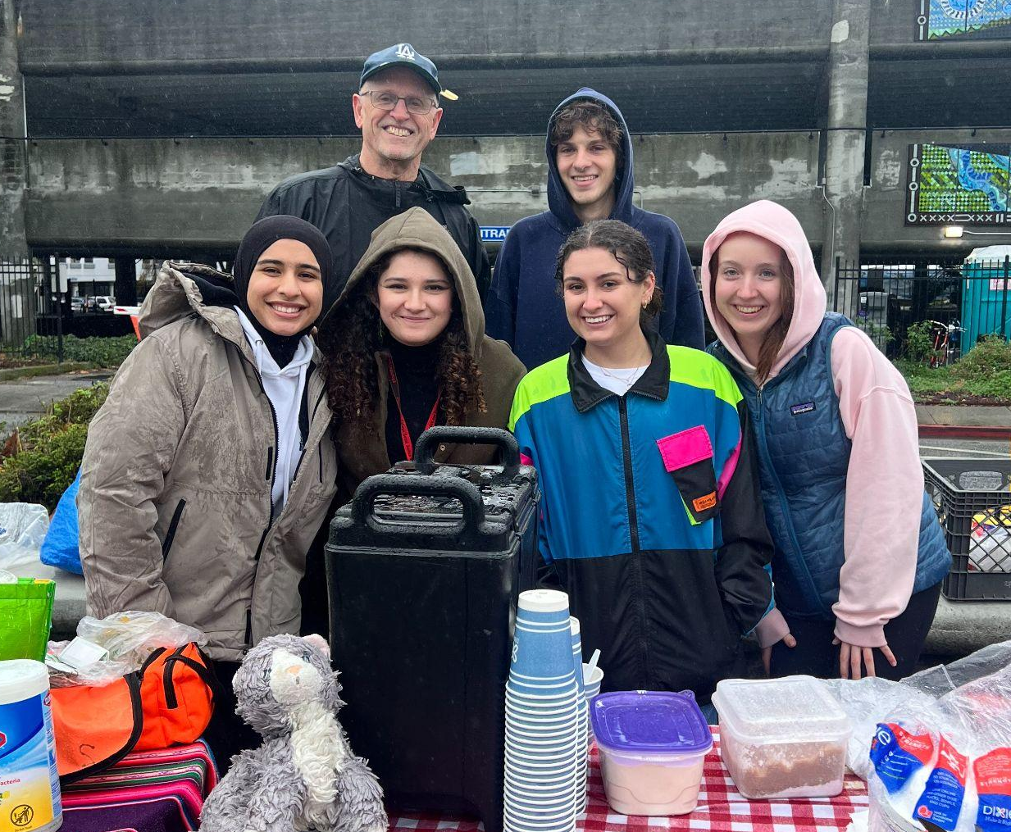

- Building Community in the time of Deportation: Join us for a Roundtable Discussion, introducing topics of how to support undocumented and immigrant populations, on February 16 at 4:30pm. 1319 Laurel St.
In response to increased threats to safety for undocumented and immigrant communities, SCBR is partnering with the local Interfaith Network to engage in community trainings. The network will focus on providing “know your rights” education, creating Child Safety Plans, and Rapid Response/Legal Observation trainings. Contact us if you’d like updates about these trainings!

