The other day while sharing breakfast, a woman coming to eat with us noted that the food at Bread & Roses is different from that of other groups because “we can tell you like yourselves, and you like us”. By “you like yourselves”, I understood her to mean that our work does not feel driven by guilt or saviorism, but by an overflowing of deep joy and calm in the experience of being human.
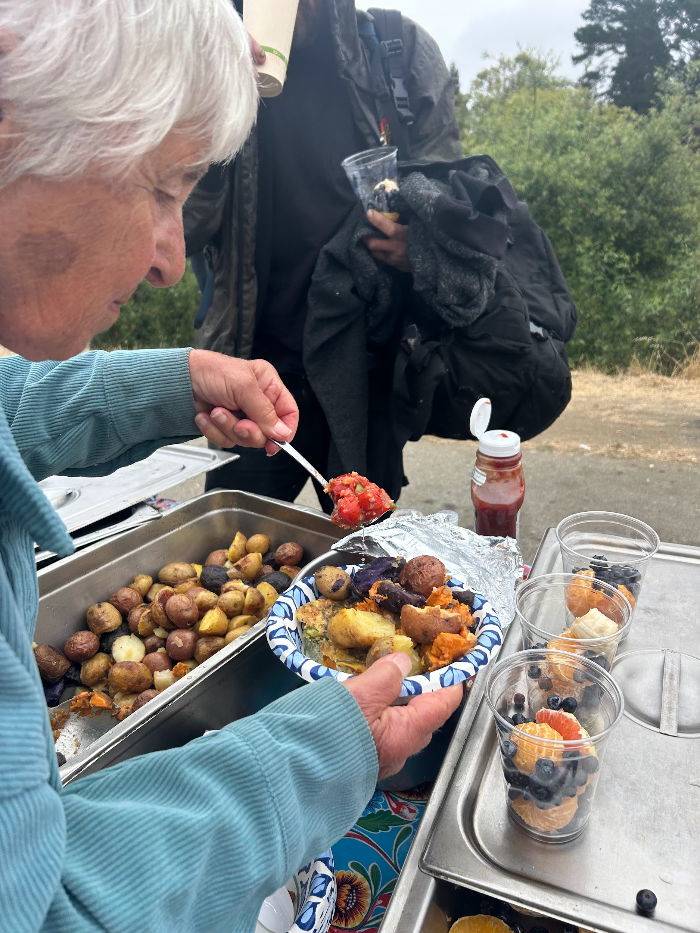
People sometimes ask if we ever have “success stories” at Bread and Roses. What I assume they usually want to know is if, after using our services, people get out of the cycle of homelessness and reenter the mainstream flow of capitalist life. In these conversations, I try to reframe “success”. As a small conglomeration of volunteers with limited resources primarily offering breakfast, our goal is not to end homelessness. We have nowhere near the capacity required to do so. Instead, our goal is to offer a reprieve from the traumatic chaos of many people’s lives, by sharing a sense of dignity and kinship. The fleeting nature of breakfast -a warm belly and softened composure for an hour- is precisely the point: we must return day by day to find humanity within ourselves and one another.
Within our framework, “success” looks like volunteers and guests meeting over a flowery tablecloth to eat from the same pot of soup. We don’t nitpick statistics of meals served, how to make the cheapest cup of coffee, or who is on track to rehab housing. I’m much more interested in Bread & Roses helping housed community members learn to look those living on the streets in the eye and see our interdependence, rather than turn away and further divide our town socioeconomically.
If Bread & Roses can assist those who live within mainstream society to recognize those on the fringes as whole and dignified, we might have a chance at re-aligning the bones of our community in that light. We do this by staying at the margins. Success here is the mutuality in which someone enjoying an ephemeral warm bowl of oatmeal in turn helps another discover their responsibility to interconnected humanity.
We’re so grateful to each of you for joining in your own way to be part of this lavish spread. We rely on your financial, physical, and moral support as we grow, so we welcome however you are able to pitch in. We hope that this holiday season, you taste a bit of the kinship and belonging we hope to share in the year to come. ❈



- Do you have blankets, adult clothing or hotel-sized hygiene supplies to pass along? Contact us to coordinate a drop-off or pickup.

- Interested in attending a volunteer training? You’ll learn valuable skills in de-escalation and trauma-informed care, as well as how to prevent opioid overdose. Sign up using this QR code, or email us→

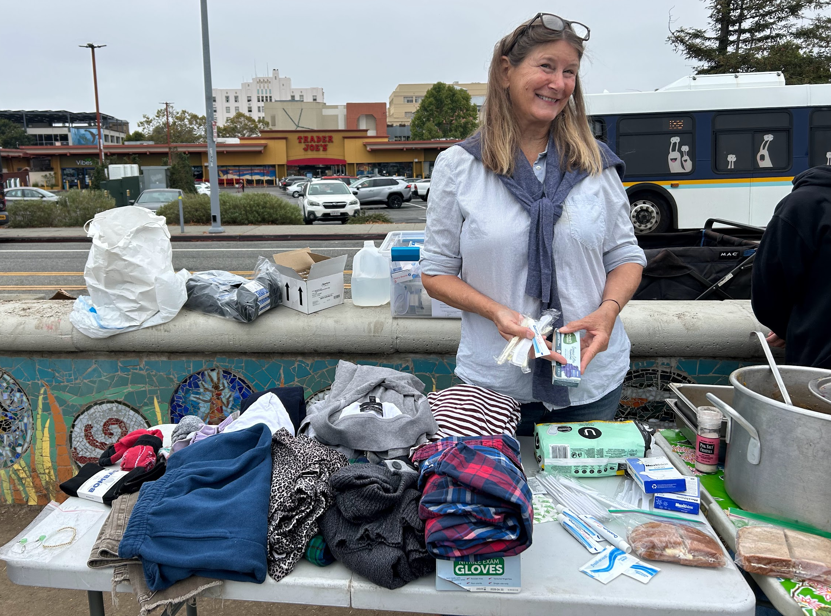

Santa Cruz Bread and Roses accompanies those experiencing homelessness and poverty in Santa Cruz by nourishing people’s basic physical needs with joy and dignity.
We serve breakfast and essential supplies for free on local streets 4 days weekly.

