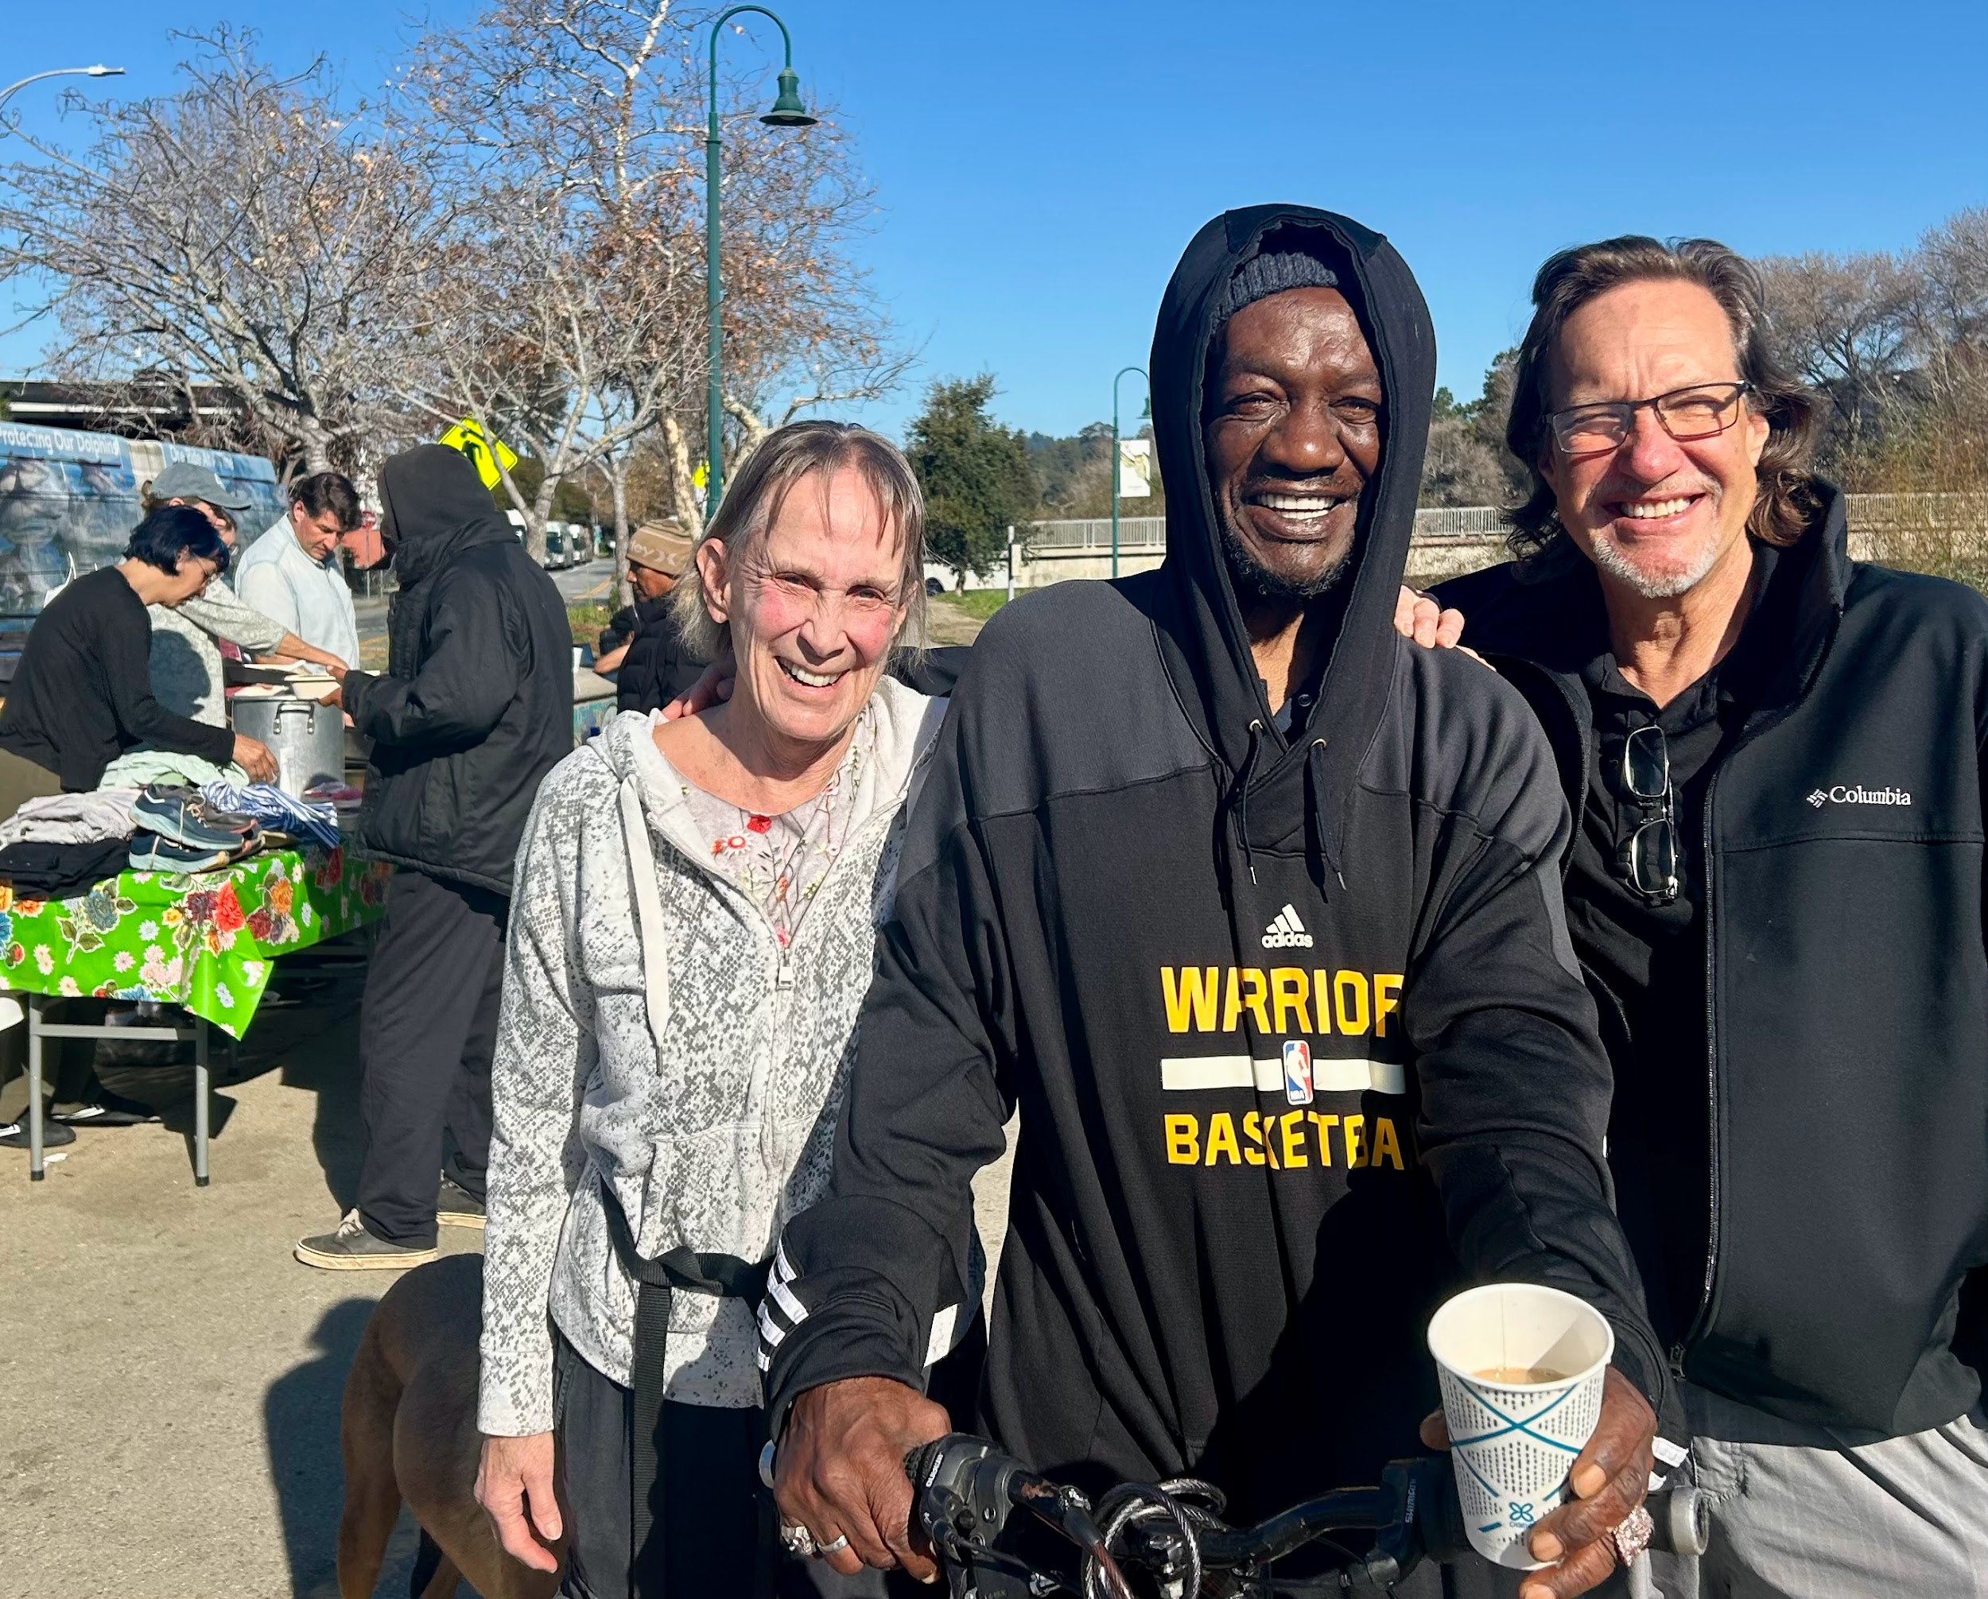
As we head into the seasons of Lent and Easter, I’m reminded of how the cycles of death and resurrection play out in our little world at Bread & Roses. For a couple of years, Roy was a guest who frequented our meals with a beaming smile and an unhurried Jamaican accent. He spent 8 years living in shelters, slowed down by an unending siege of physical ailments. His presence and reggae music brought an atmosphere of calm and delight to our meals.
Then one day, he stopped showing up. Months went by. One guest told us he thought Roy had passed. The genocide in Gaza raged on, ICE was deployed locally, and we still found ourselves wondering what happened to Roy. We only feel the weight of big grief through the smallness of personal pains afterall.
One recent sunny morning, Roy rolled up on his bike, grinning as ever. “I got housing!” he hollered. We were ecstatic. He told us of his life now, healthy, calm, and confident. Even as oppression flares all around, I rejoice in the glow of Roy and our volunteers celebrating his new phase of life. To me, that is the image of Christ: resurrection, even and especially in the midst of empire. ❈
Join us!
On February 27, please join us for a Creative “Show and Tell” and craft night! Bring a poem, painting, song, short story, or anything creative you’d like to share. We hope this will be an opportunity for togetherness, light, and hope. Pizza will be provided. 6pm; 1319 Laurel St. Santa Cruz
Are you interested in helping us deep clean the kitchen? We’ll give the lovely kitchen at SC Bible Church a spring cleaning February 27, starting at 9am. Email us if you’d like to help.
On Friday March 20, we'll co-host a Roundtable Discussion on "Spirituality and Resistance" at the Villa Maria del Mar retreat center. More info soon. 6pm- 21918 E. Cliff Dr.
Looking for ways to support immigrant and undocumented communities locally? Check out Santa Cruz YARR for trainings and events.

- Can you make a monthly financial donation? Contribute to our current work and help fund the future Bread & Roses Cafe, a hub providing nourishing food on a sliding-scale payment model, basic supplies, and a sense of belonging for all. Mail a check or use the link at right: PO Box 2142 Santa Cruz CA 95063

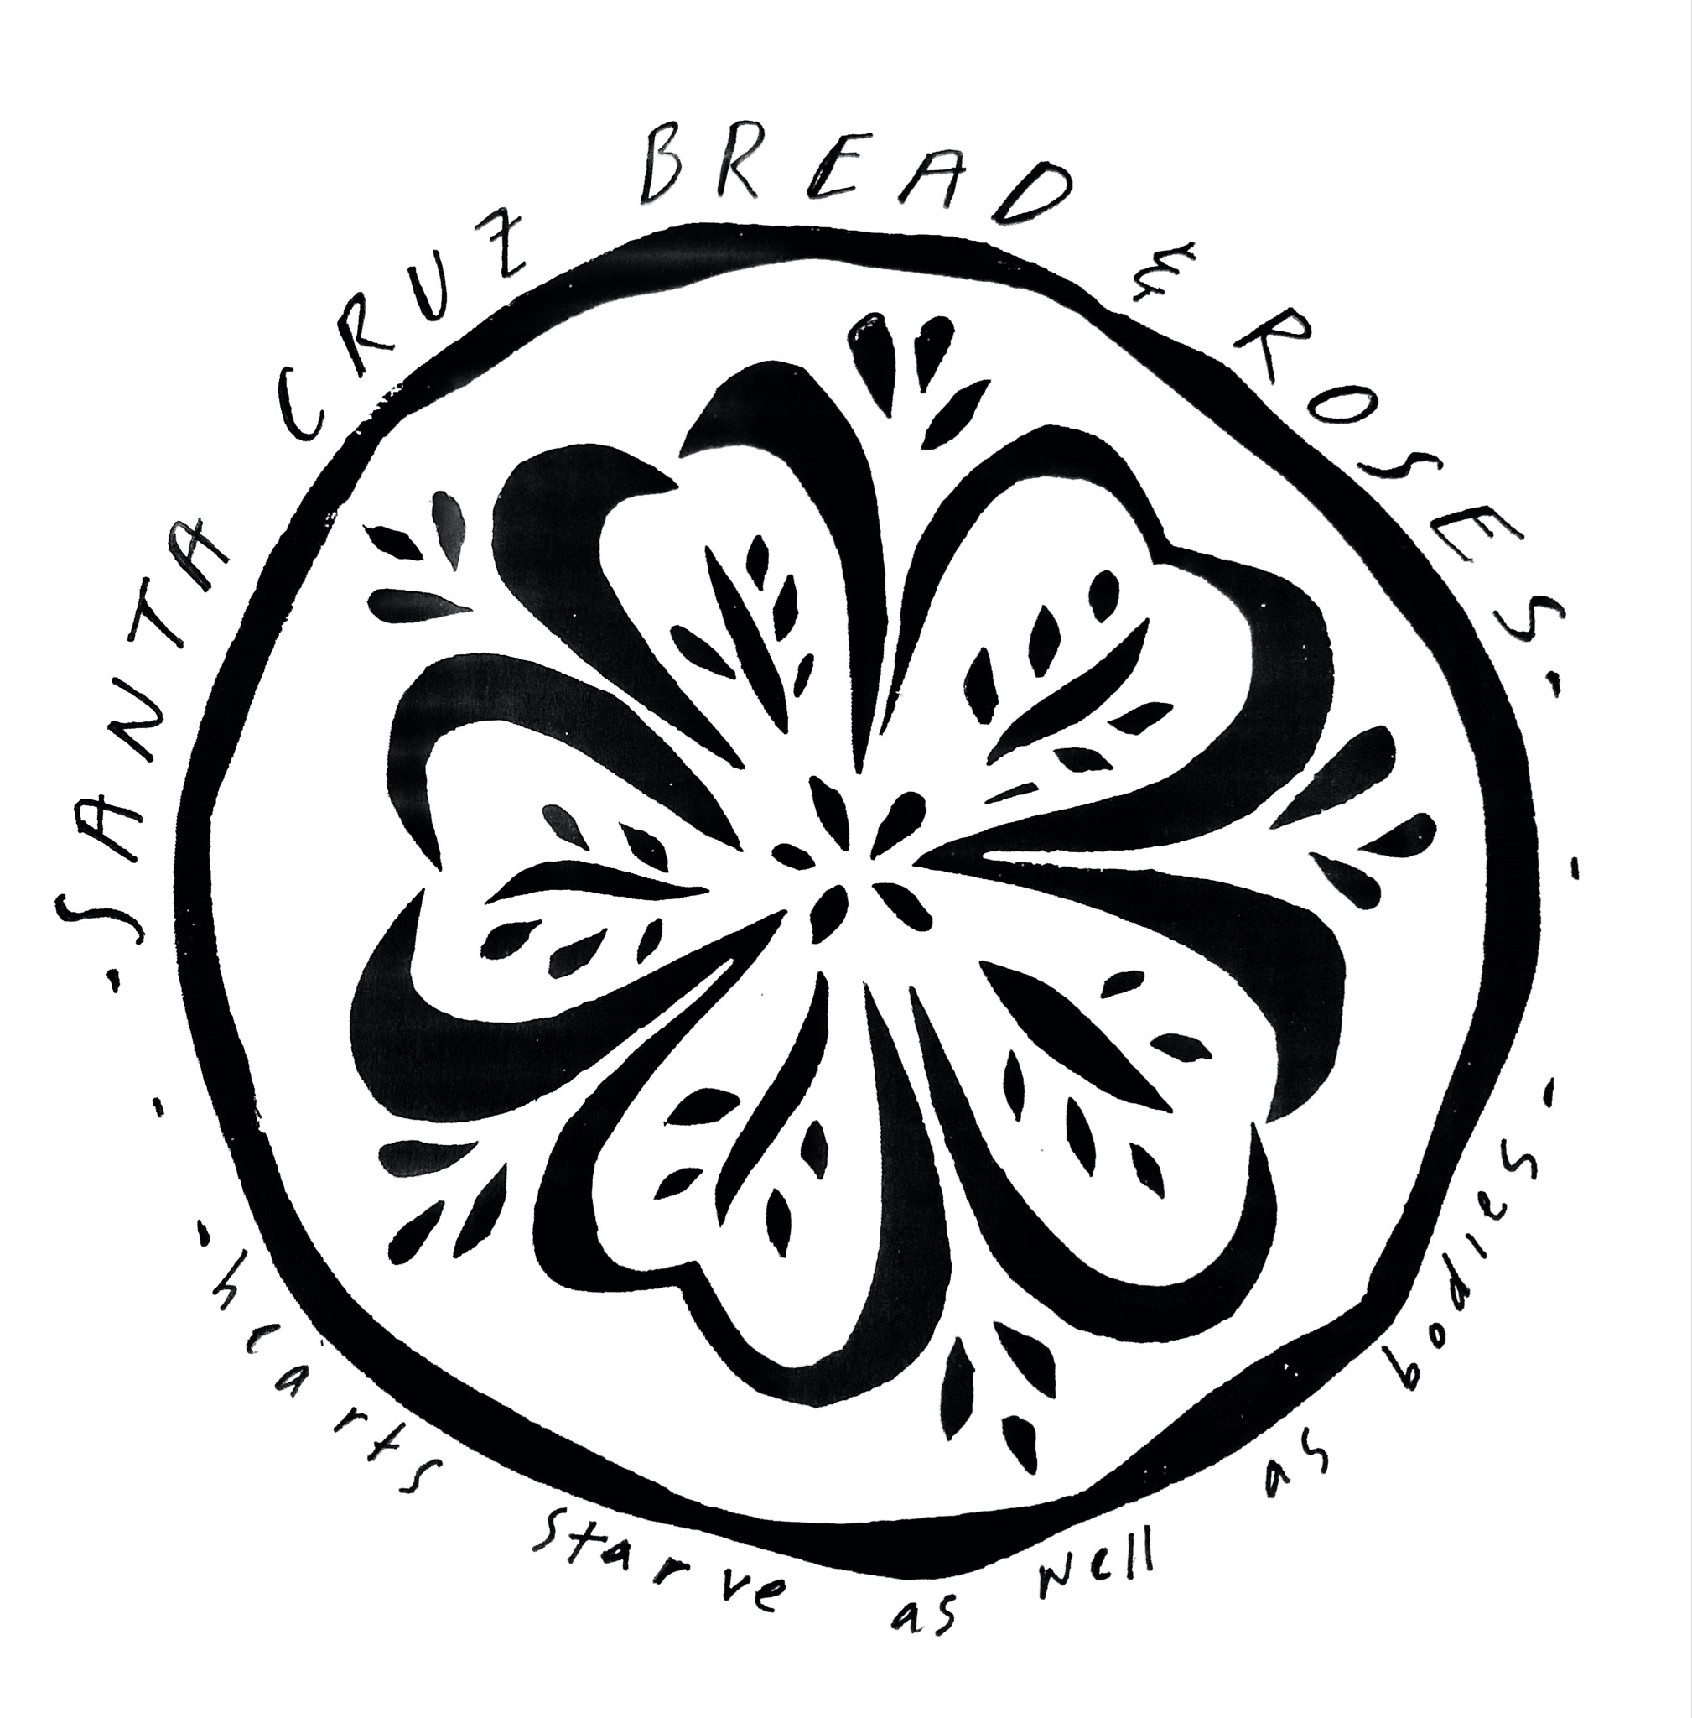

Santa Cruz Bread and Roses accompanies those experiencing homelessness and poverty in Santa Cruz by nourishing people’s basic physical needs with joy and dignity.
We serve breakfast and essential supplies for free on
local streets 4 times weekly.

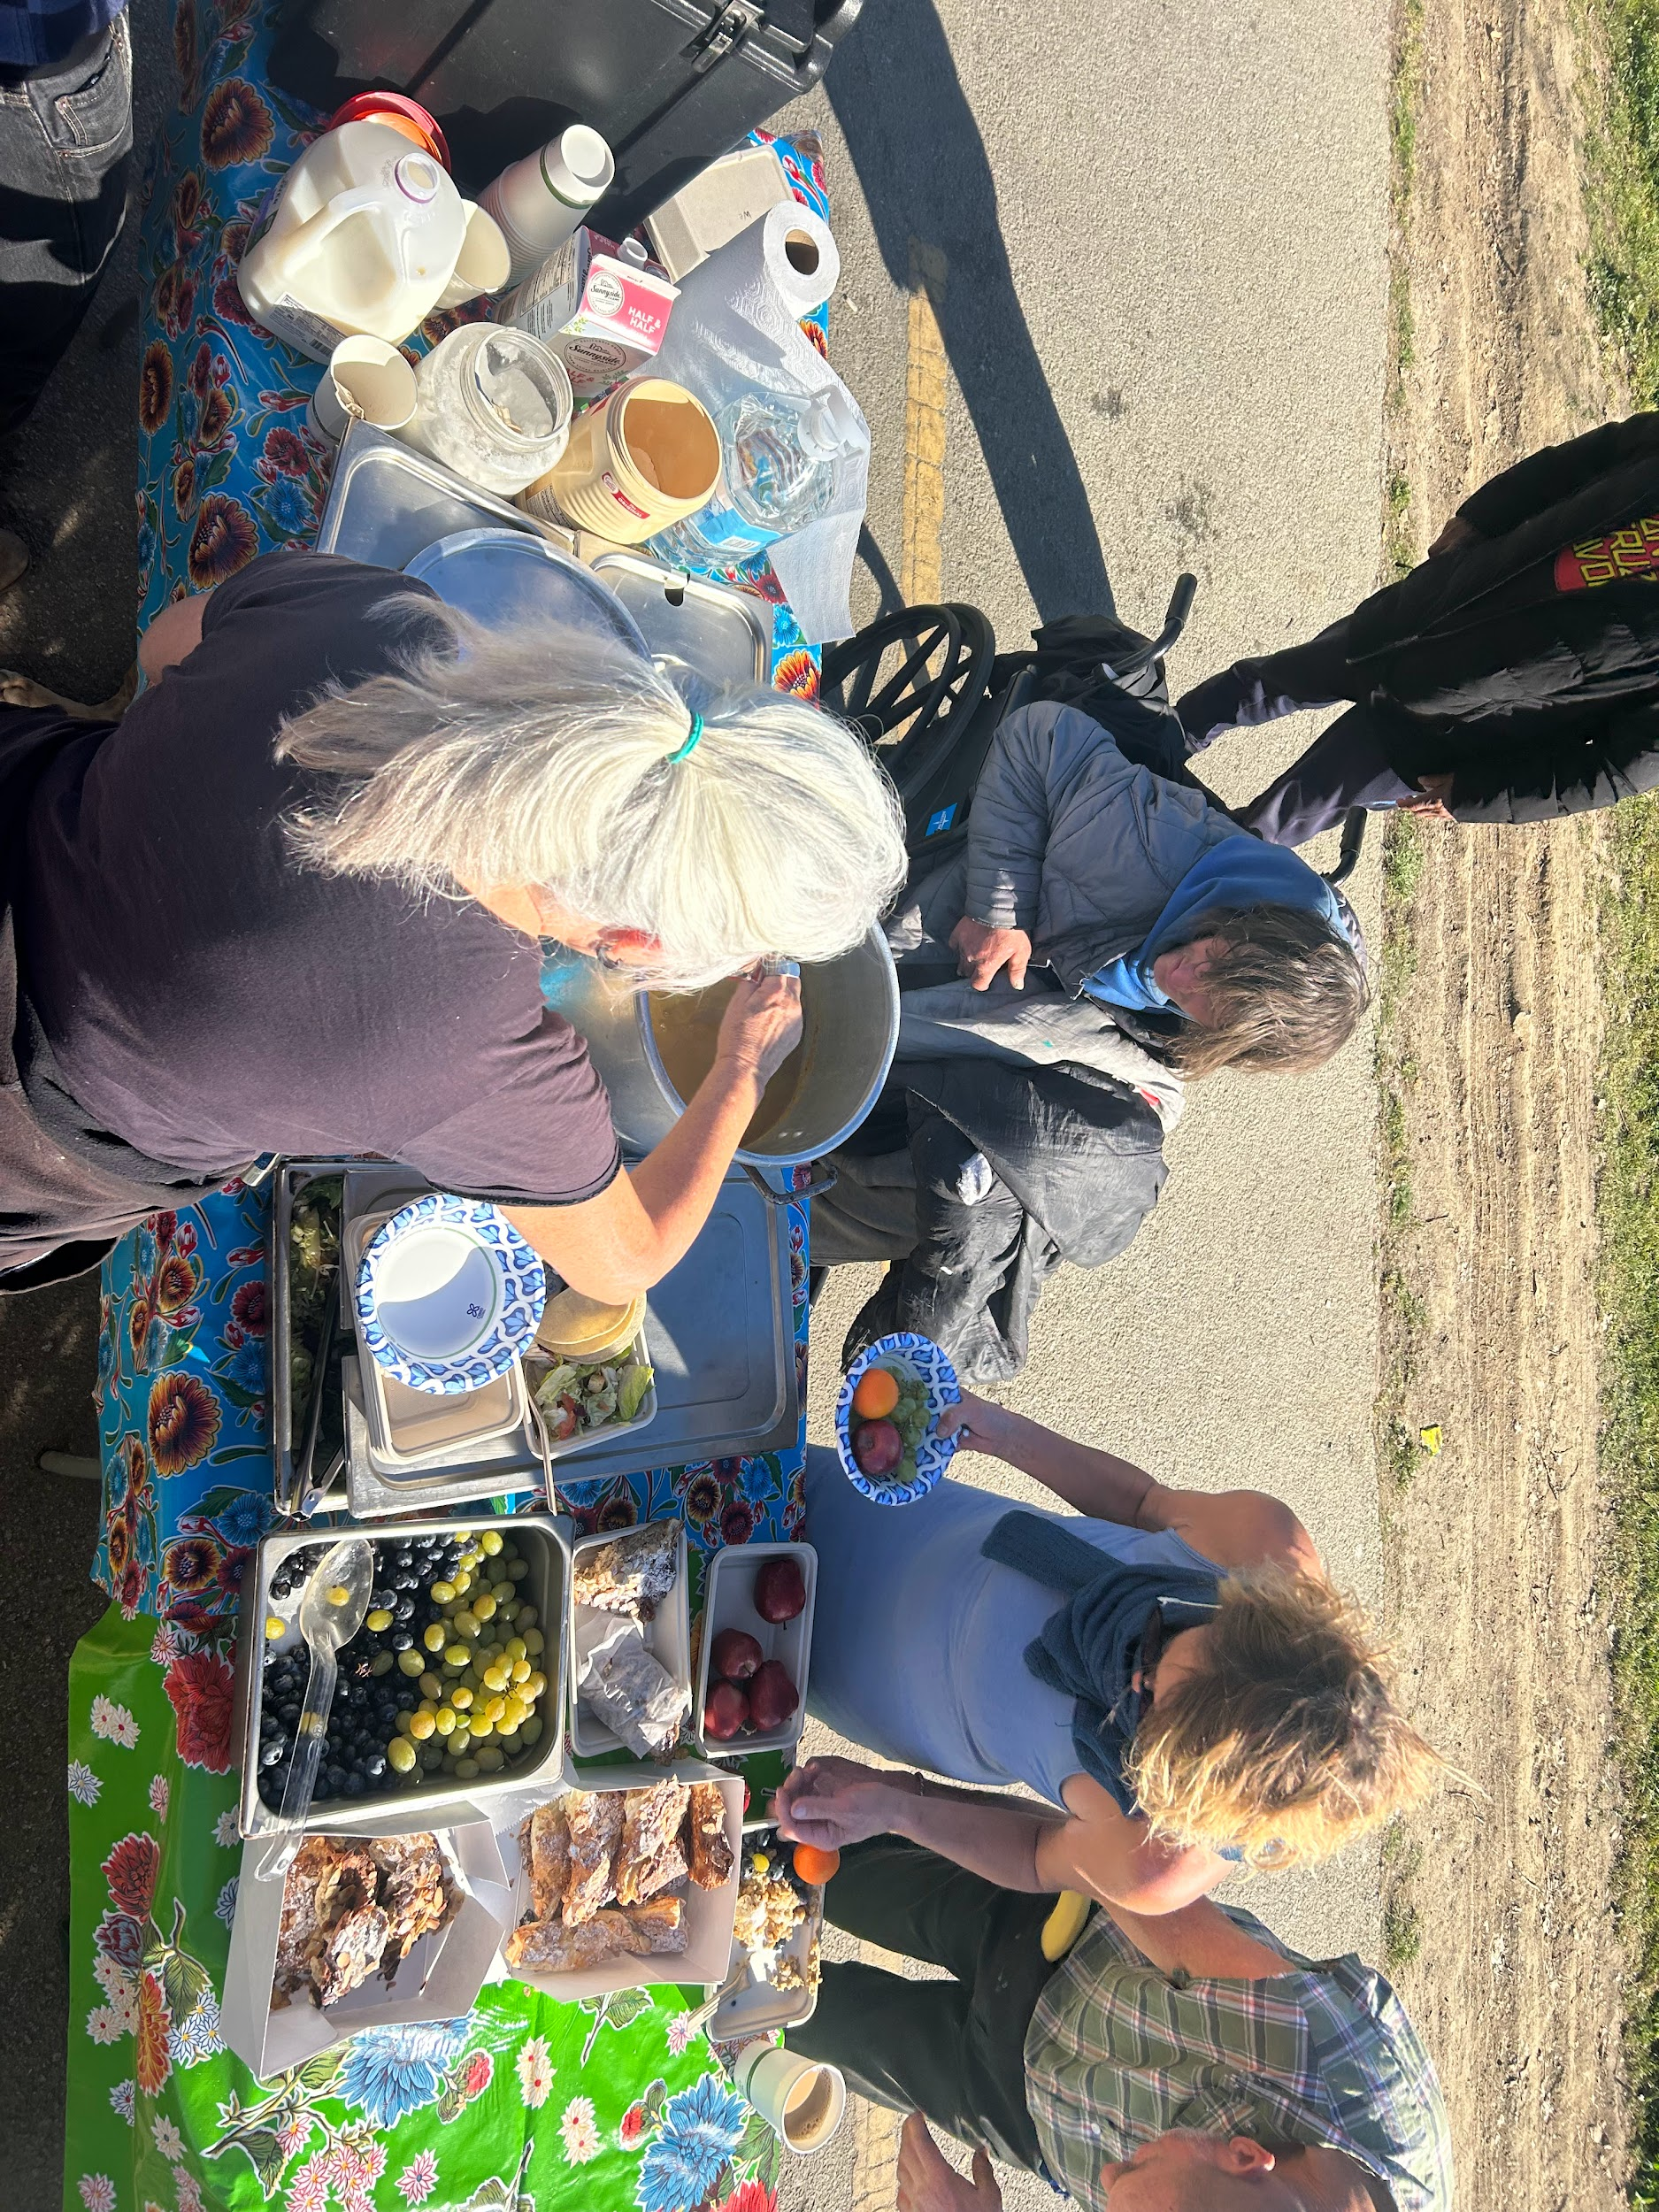

Upcoming Events:
- February 27, 6pm- Creative Show and Tell
- February 27, 9am- Kitchen Deep Clean
- March 20, 6pm- Roundtable Discussion: "Spirituality and Resistance"

