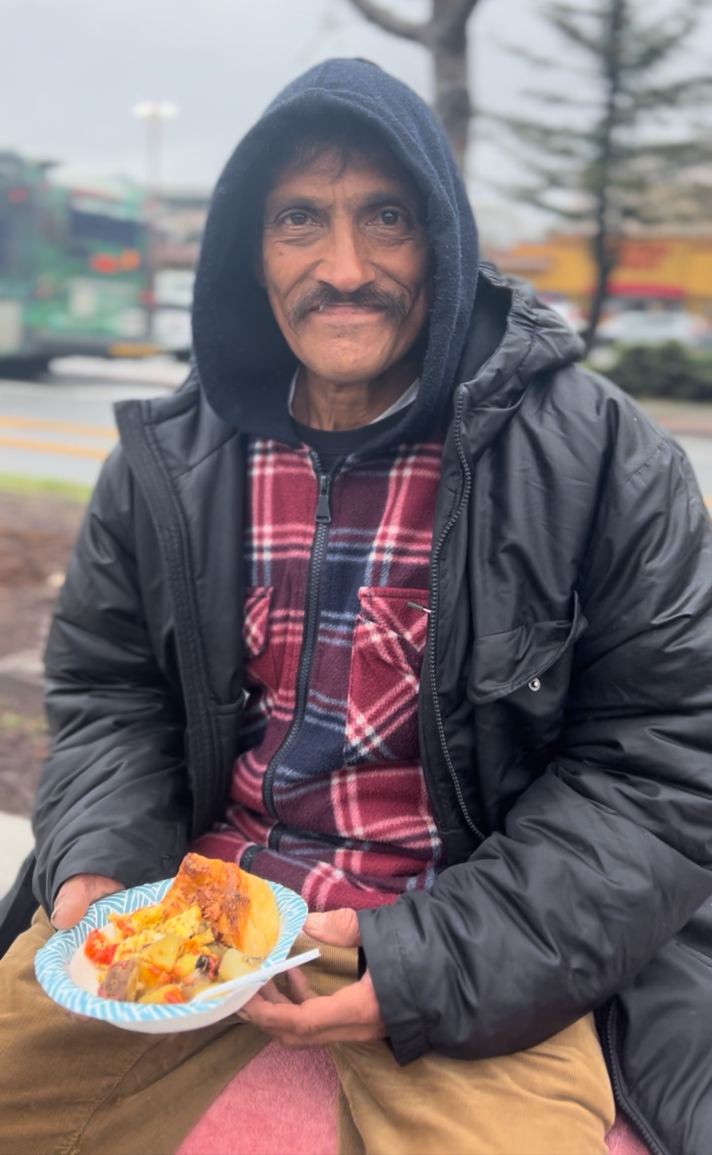
Recently, one of our regulars, Simon, asked if he could write a reflection on what Bread & Roses means to him. I handed him a few sheets of scrap paper, and the next week he returned with 3 pages of carefully scrawled words on our behalf. He encouraged us to share his letter with the community, and expressed hope that his words would garner more support for the meal gatherings he frequents with us. We’d like to share a section with you:

“Bread & Roses is a welcome sight, and rain or shine, they remain consistent. [They are] ever ready to listen and bring smiles and to inspire more-fulfilling ways to live. B&R brings light to where only shadows used to exist.
A kind word is not missed, and [there’s] plenty of moral support.
Bread & Roses is about compassion, understanding, meeting basic needs, and providing… a source of empowerment by providing truly vital and essential food for mind, body and soul.
Being genuine and ever-ready to serve and protect all in its midst, B&R has served a lot of individuals in for too many woes, and it would benefit a lot of people if Bread &Roses were given a place all could utilize as a means to gather one’s thoughts and fulfill the things that bring smiles and joy to our hearts and minds.
Bread & Roses continues to instill and also generate positive behavior. We the homeless and those struggling to live by society’s standards are truly grateful and support Bread &Roses in their daily tasks to give and provide to ensure that all are able to feel welcome.
In short, we ask that all join in our efforts to be a vital source in providing all with nourishment, dry clothes, and kind loving words.”
-Simon

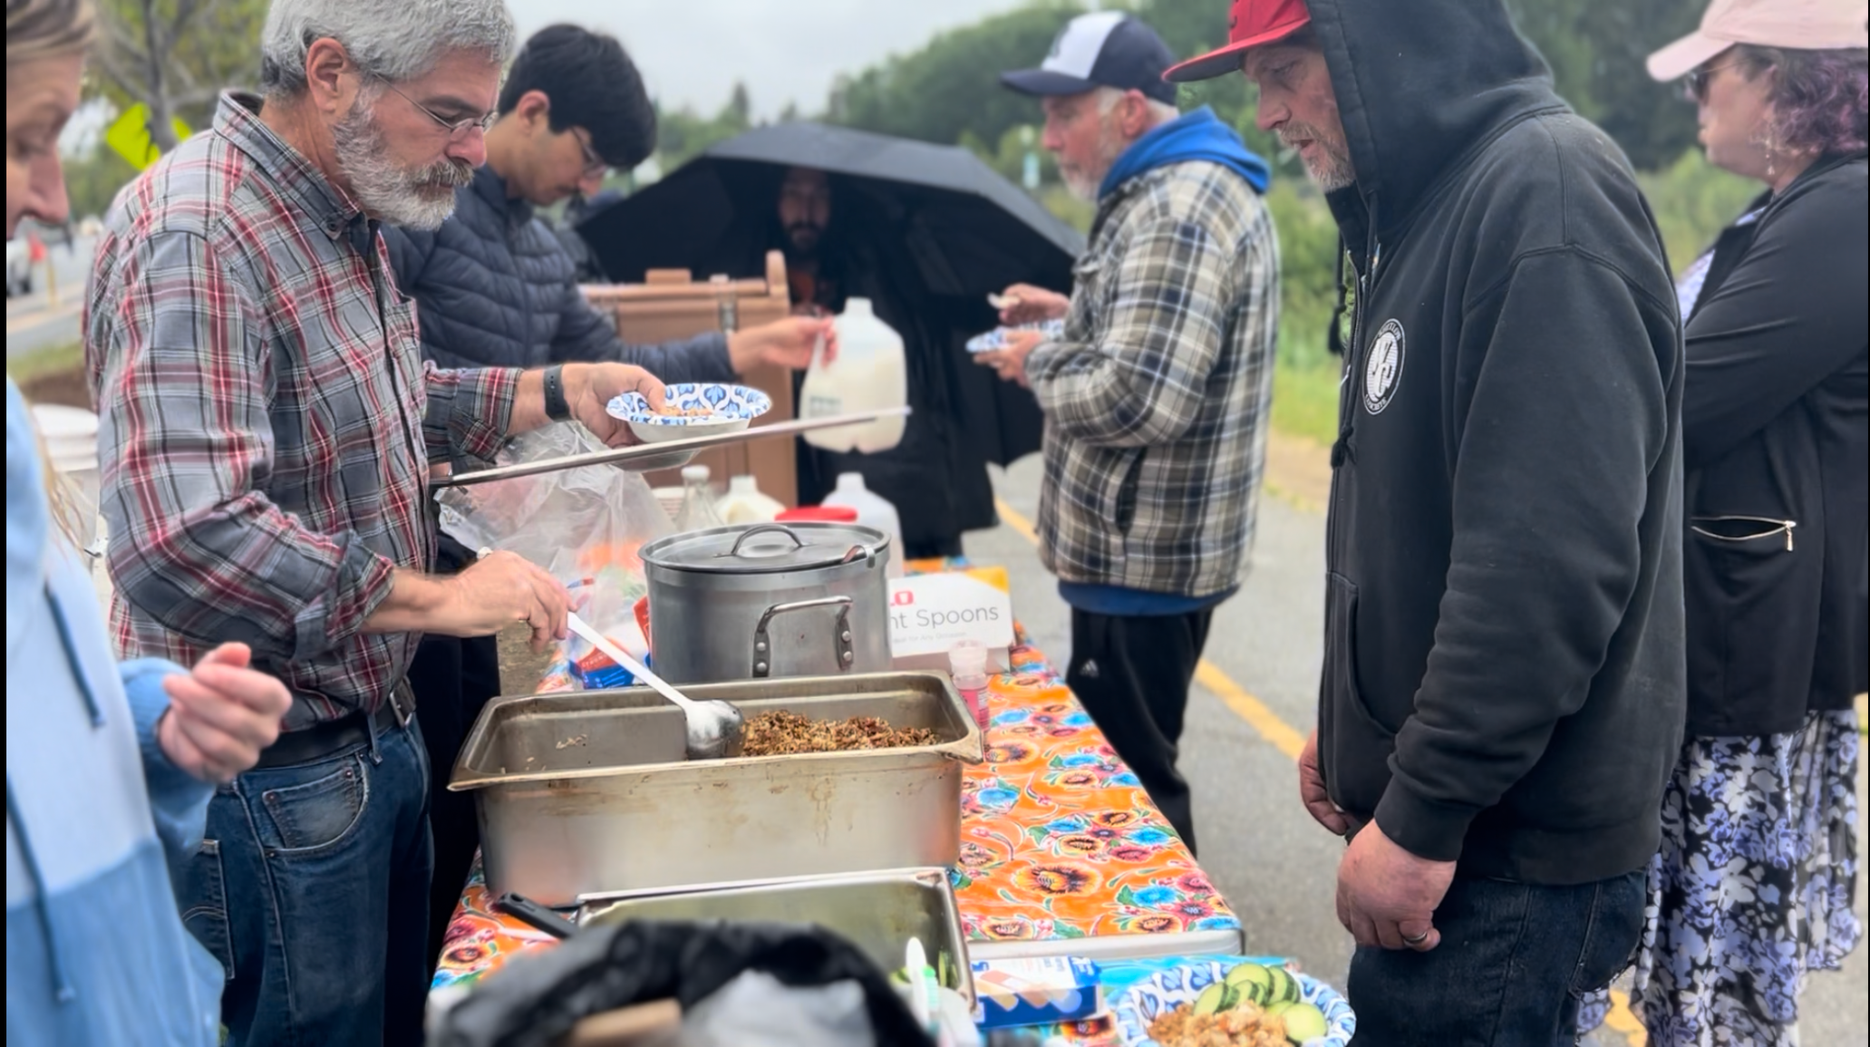
While many like Simon eat with us and express gratitude at the regular meals, volunteers also often note how the gatherings cultivate a meaningful and kind community for them as well.
We are deeply grateful for each person’s contributions to keep the fires of this communal effort tended and sustained. We invite you to consider how you may participate as well, whether through cooking, serving, gathering resources, or donating funds. We appreciate you! ❈



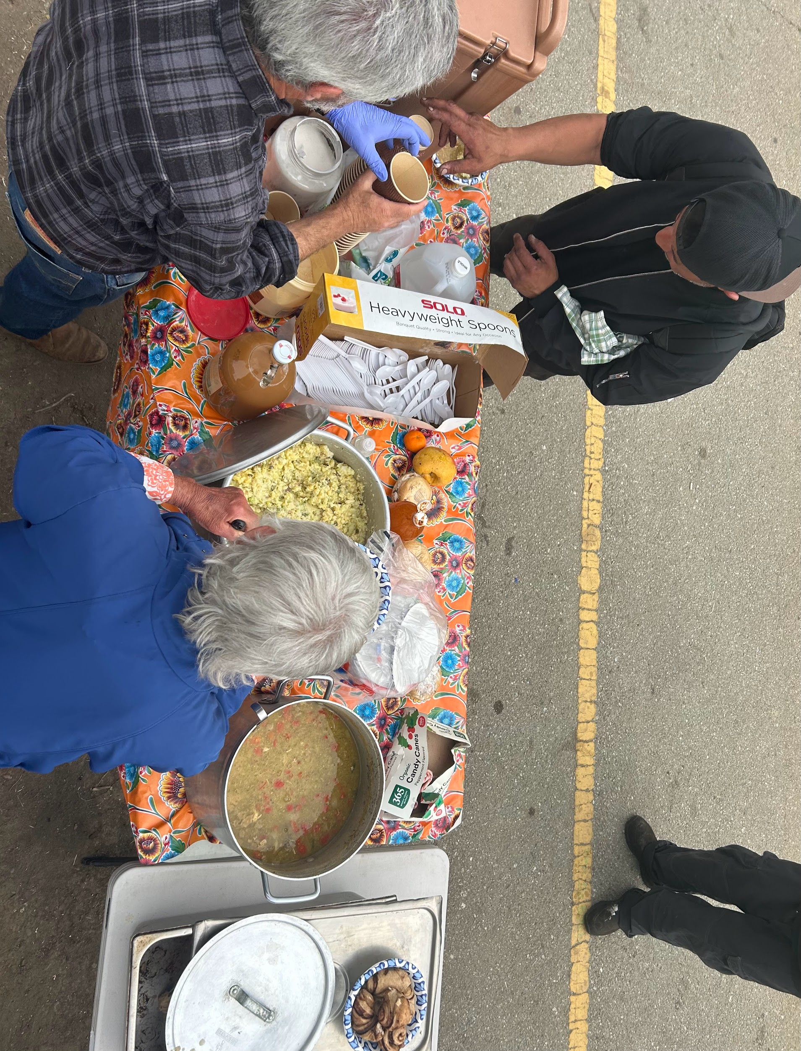

Santa Cruz Bread and Roses accompanies those experiencing homelessness and poverty in Santa Cruz by nourishing people’s basic physical needs with joy and dignity.
We serve breakfast and essential supplies for free on
local streets 4 days weekly.




- Interested in purchasing a SCBR sweatshirt, hat, or shirt to show your support? All proceeds go straight to our work on the streets. Visit us online or email us for sizing info and to order.

- Do you have adult clothing to pass along? We’ll also happily accept hygiene supplies. Contact us to coordinate a drop-off or pickup.

