Lao Tzu says,
The one who sees the small is called clear-headed
The one who holds to gentleness is called strong
Use the light
Come home to your true nature
Don’t cause yourself injury
This is known as seizing truth

SCBR is an exercise in going to our city’s geographic and sociopolitical periphery to see those making their lives in tents alongside rising creeks or sleeping in cars at risk of midnight tows. We attempt to seize truth, as Lao Tzu writes, in the simple acts of bringing dry clothes, hygiene supplies, hot breakfast, and friendship, all in the spirit of accompaniment.

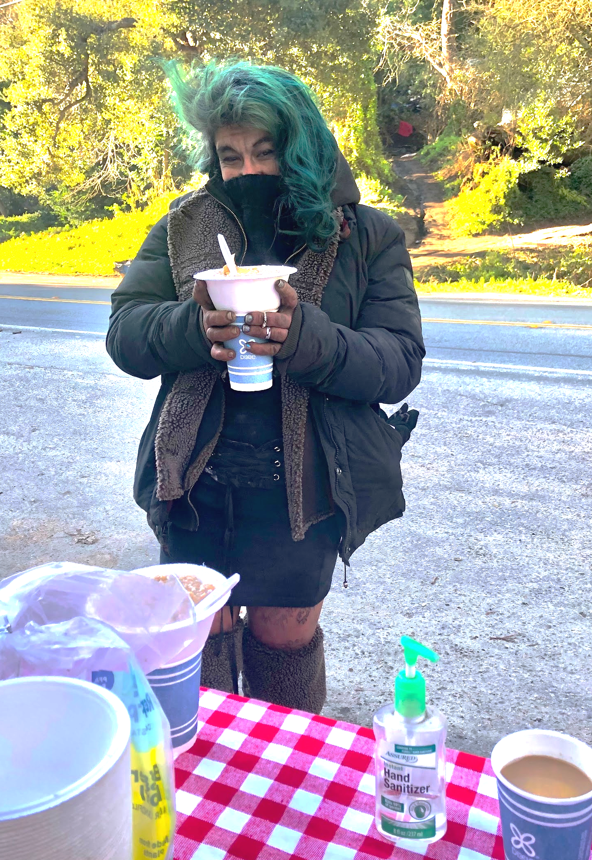
Our time in the encampments does not define either party as the mere ‘giver’ or ‘receiver’, but rather allows each of us to participate in the collective care that brings us back to ourselves. Just as much as my neighbor may need dry pants and a bar of soap, I need reminding of how to stay soft and gentle in a culture that incentivizes military might, corporate land-grabbing, and self-promoting media. The folks living outside often help us set up, serve the meal, and share laughs. They label hanging bags of Narcan from trees in communal areas to protect one another from the realities of overdose. David walks a steaming bowl of banana pancakes and a new rain tarp up the steep muddy hillside of Highway 9 to find Trey, a friend recently released from the hospital and fighting infection while living in his makeshift tarp shelter. Their gratitude brings hope to those of us dissatisfied with the current system that injures and isolates both rich and poor.
We seek this table-turning wisdom of humanity’s gentle true nature, and hope you’ll join by sharing in the springtime opportunities listed below!

Bi-weekly Breakfast Club: Join us in bringing breakfast to Santa Cruz encampments, or donate food, coffee, rain gear, new underwear, and warm adult clothes. Contact us for location details.

April 30th, 4pm: We are excited to begin hosting a small monthly ecumenical liturgies for contemplation and prayer. We value our action being grounded in the fire of love and stillness; this is an opportunity to gather around the common centrality of justice and peace within our varying traditions and practices. Each liturgy will offer guided silence, communal thematic exploration, and a potluck. Location to be determined, so please RSVP soon!

Check out our website for recycled, hand-printed SCBR clothing! Proceeds benefit community work.

With heavy spring storms, we continue bringing nourishing meals and warm supplies to the main Santa Cruz encampment. We are fundraising to buy a space to expand ministries.
~
Can you lend a hand? We can use the following donations:
- Rain gear, new underwear, hygiene supplies and warm clothing
- Food (especially peanut butter) and coffee
- Financial donations for the Bread & Roses location, a cafe-like setting where people can come for basic supplies, a sense of beauty and belonging.

www.scbreadandroses.org ~ scbreadandroses@gmail.com

