Teilhard de Chardin wrote that “The most personal is the most universal”. The divine is revealed to us as we encounter the raw sensory experiences of folks living on the streets:
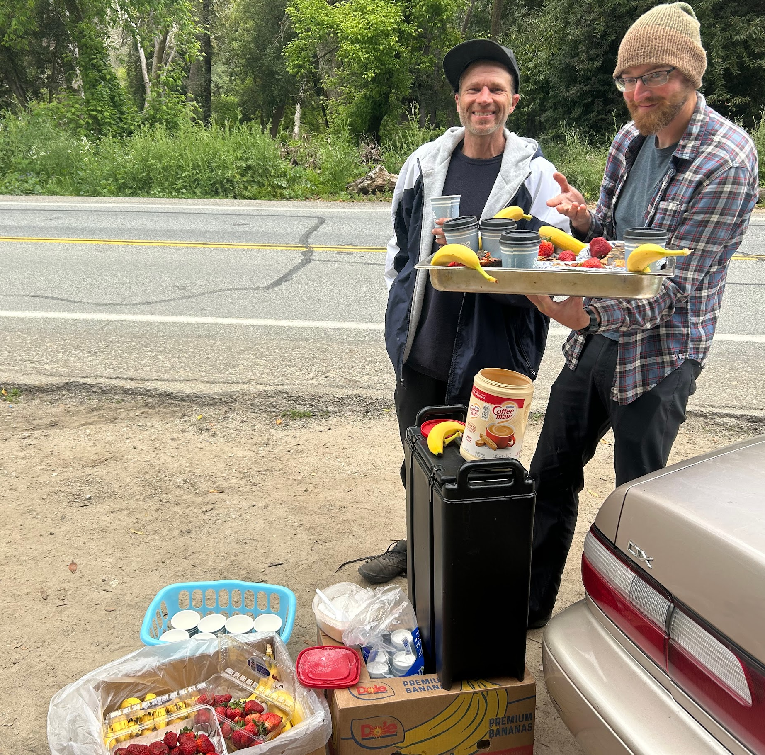
On a recent Monday morning, a couple of us drove to meet those we’ve come to know in local encampments. We stacked the backseat high with trays of roasted potatoes and veggies, eggs, fresh fruit salad, and a thermos of steaming coffee. Instead of the grateful smiles and enthusiastic greetings we usually receive by the dirt turnout, we were met with caution tape, bulldozers, and police cars. They guarded the now vacant forest previously inhabited by those edged out of the city’s economic and social spheres. Yet again, hundreds in our town had been thrown into the chaos of lost belongings, scattered community, and the search for new refuge.
A friend who we often meet and feed on the streets lent a hand serving those who found us through the turmoil. He lives in his car, and found us that day because his car had broken down there several days prior. He spent the rest of the morning offering nourishing food and hygiene resources at the SCBR table, so that other volunteers could scale the hills carrying meals to folks who had fled the sweeps.
As SCBR we go out to find people where they are and carry the resources we have, and those outside come to us with their creativity, insight, and gracious helping hands. We find that the division between ‘server’ and ‘guest’ is repeatedly erased, leaving only ‘human’. We come home to ourselves by finding this universal heartbeat in the personal “little things with great love”, as Mother Teresa would say.

What’s happening this summer?
- Roundtable discussions- Please join us for a staple of the Catholic Worker tradition where we connect mind, heart and spirit to the pressing systemic themes of the day. Both Roundtable Discussions will be hosted by David DeCosse at his home at 1319 Laurel Street, Santa Cruz. Refreshments provided.
- Friday, July 21, 5:30-7 p.m.: Dorothy Day’s The Long Loneliness, and “Homelessness in California”.
- Friday, August 4, 5:30-7 p.m.: Hiroshima and the Challenge Today of Being a Peacemaker: An audio recording of a survivor of the Hiroshima bombing, and a discussion between Pema Chodron and bell hooks. Contact us to RSVP!
- First annual summer fundraiser- Gather with us Saturday September 9 from 5-8pm for live music, catering by India Joze, and a raffle of local crafts to benefit SCBR’s growing work. Location TBD.
- Bi-weekly outreach: Contact us to volunteer or donate clean clothes, hygiene supplies & food.

Save the dates!
- July roundtable discussion- July 21 and August 4, 5:30 pm. 1319 Laurel Street, Santa Cruz

- First annual summer fundraiser- Saturday August 12th, 5-8pm. Location TBD.

- Can you make a one-time or monthly financial donation? Contribute to our current work and help fund the future Bread & Roses location, a free cafe providing basic supplies, and a sense of beauty and belonging. Mail a check or use the link below:
1319 Laurel Street Santa Cruz CA 95060


