Santa Cruz Bread and Roses

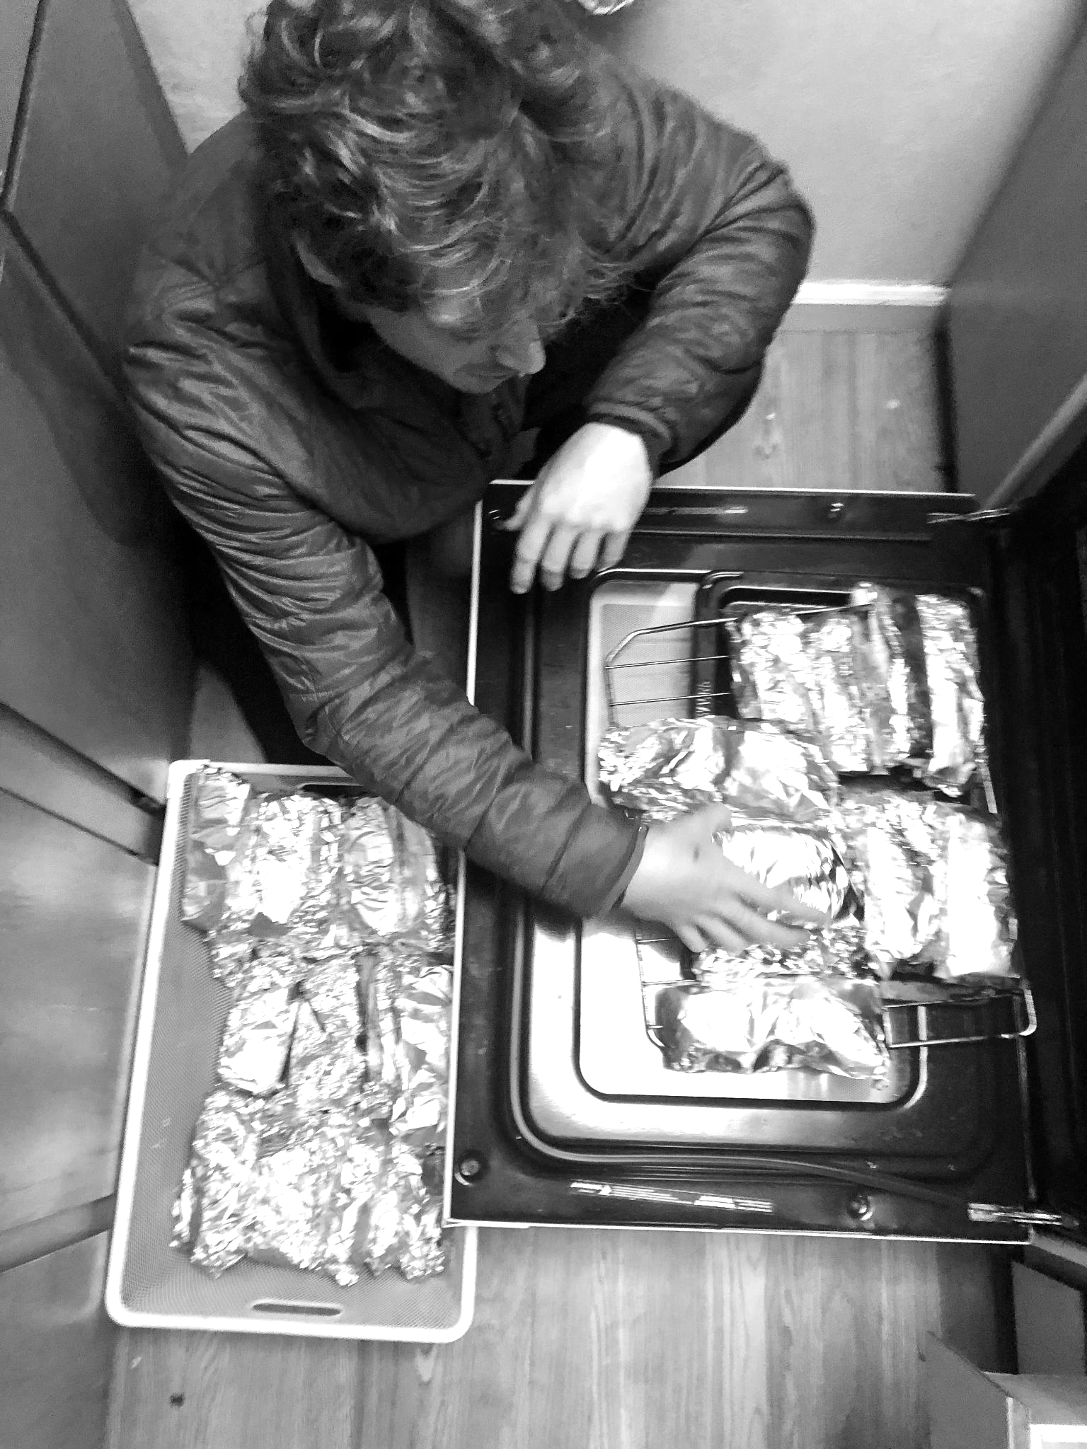
Amidst heavy rains and freezing temperatures this fall, Santa Cruz city officials swept the main encampment where hundreds living outside had built community over the last year and a half. As they’ve dispersed in the transitions, we have sought to connect with and support those we have come to know well through our weekly “Breakfast Club”. We take hearty breakfast burritos, coffee, warm socks and jackets along railroad tracks, behind warehouses, and into the forests where our friends scramble to establish their new sense of home. The day we found groupings of people we recognized now camping in a forest miles from the town center, they exclaimed, “You found us!” “Of course,” we responded, “We’ve got to look out for one another.”

While a variety of local homeless organizations offer services for people who have relatively sound minds and commitments to change, we see the gap for those ravaged by mental illness, addiction, or trauma. For them, the prospect of “progress” toward jobs, life indoors, or otherwise assimilation into traditional definitions of success remains not just a distant hope but an ever-elusive external measure of worth.
It’s for these friends that we exist.

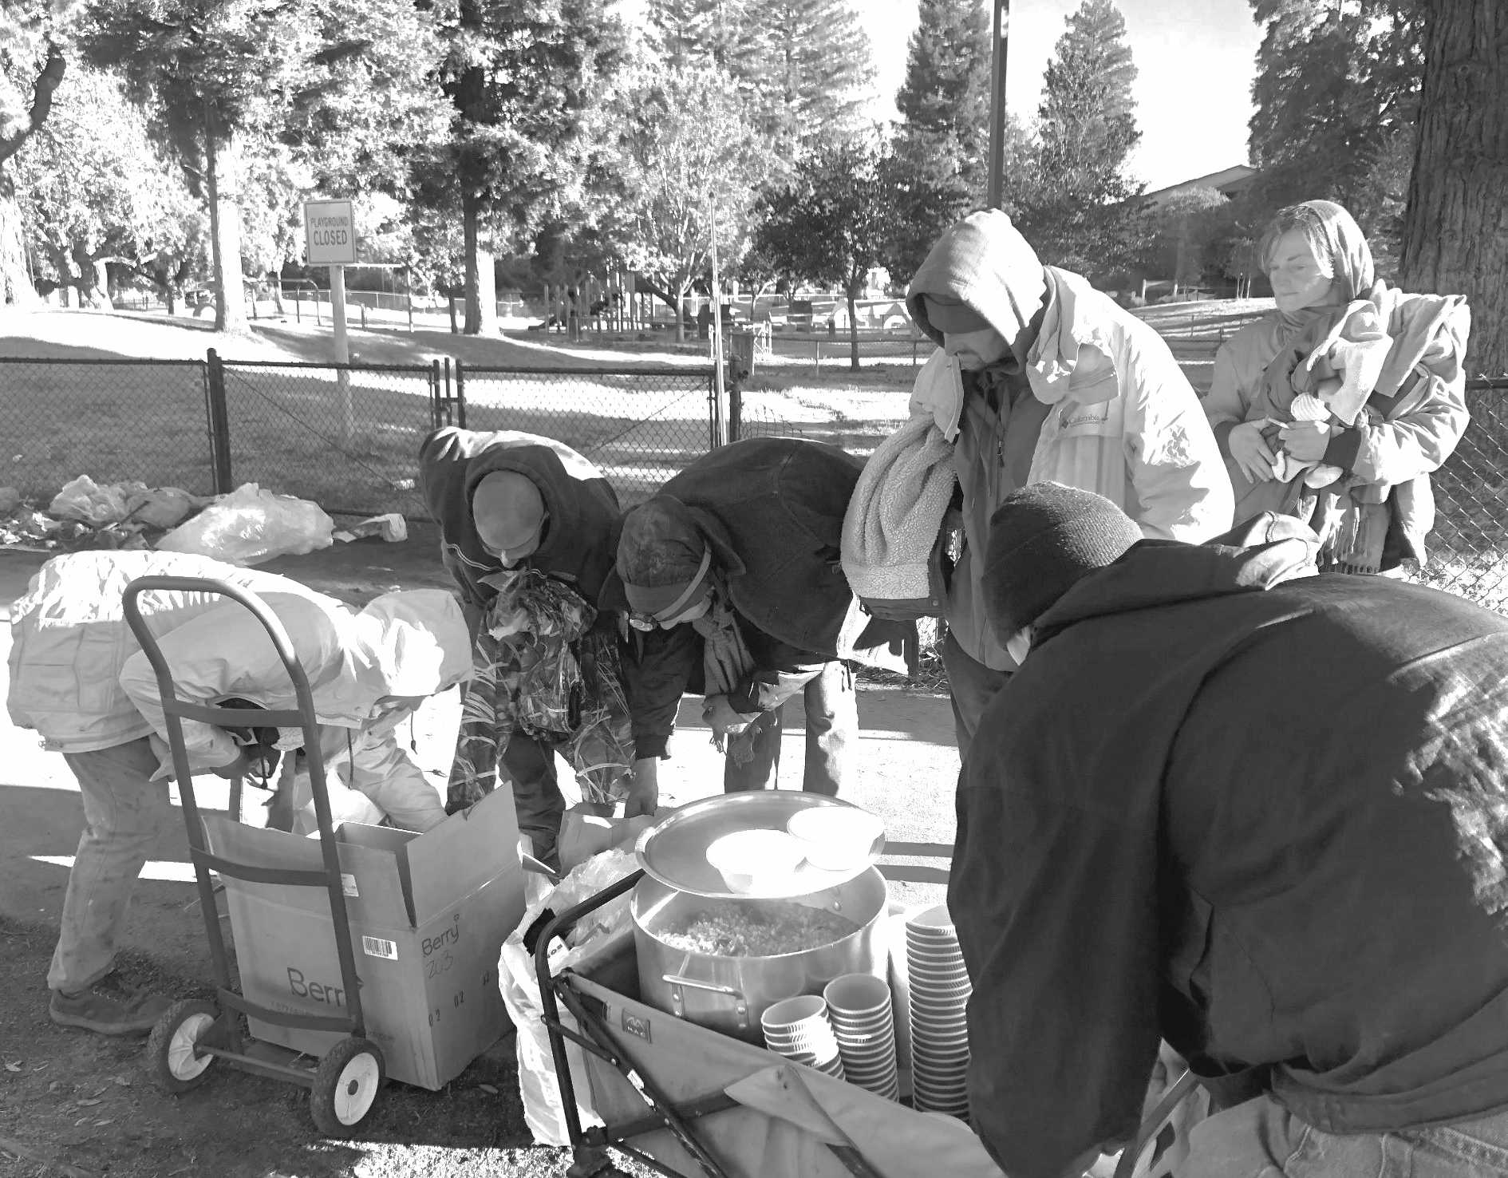
I think of Christine, the woman standing under the freeway overpass calling out eerie nursery rhymes and surrounded by inhalants, or Greg as he stares into a trash can, seeing depths we will never know. Even these people deserve nourishment of body and spirit. A wholesome meal, a place where their name is known and presence is celebrated, where they can take a breath from being shuffled and hassled, to simply be.

Serving on the streets, I have seen how a space of hospitality can allow the cloud of chaos to clear for people to recognize their talent, potential, and desire to take the next step on their path. Even if that step never comes, communal care is worthwhile in and of itself for the sake of human dignity. We will expand this spirit of hospitality through the Bread & Roses location, a cafe-like setting where people can come for basic supplies, a sense of beauty, and belonging. You can partner with us by giving through the links below or mailing a check to the following address. Many thanks!

For December-January donations up to $1000 will be matched by a partnering organization.
As we now have 501c3 status, all donations are tax-deductible.
www.scbreadandroses.org ~ 1319 Laurel St. Santa Cruz CA 95060

Santa Cruz Bread & Roses
1319 Laurel St
Santa Cruz CA 95060

For December-January, donations up to $1000 will be matched by a partnering organization.
As we now have 501c3 status, all donations are tax-deductible.

We deeply appreciate the following contributions through the winter:
- Rain gear, camping supplies, and warm clothing for displaced people
- Food (non perishable or produce) for serving hot meals in encampments
- Hygiene items and new underwear for people recently released from jail
- Financial donations towards the Bread & Roses cafe



