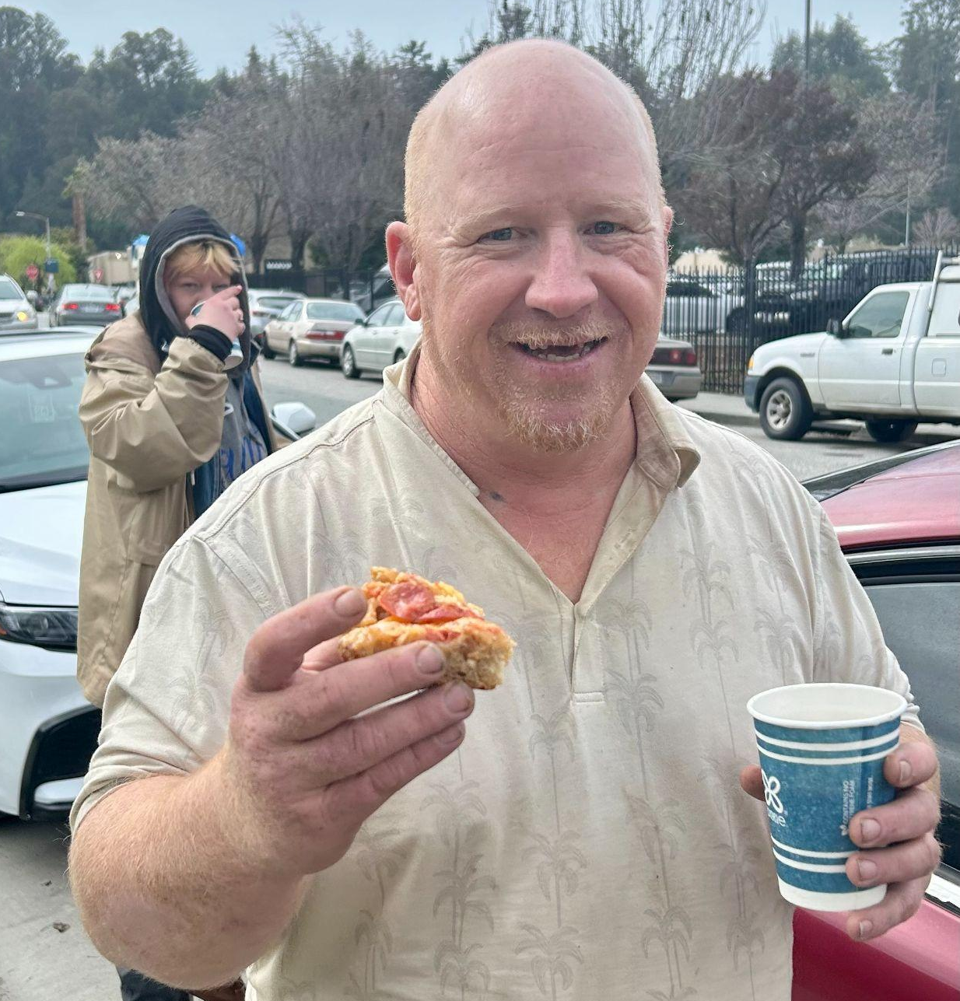
I had often seen Philip on various busy street corners, sweeping up debris and picking up trash while his laughably-large white husky patiently stood watch. Philip’s insistence on tidying up the often overlooked and chaotic intersections while jamming on a boombox impressed and intrigued me. The other day, Philip came to eat breakfast with Bread and Roses, and told us how he had walked from Eugene, Oregon to Santa Cruz with his dog Wally, picking up trash along the way. He looked down, “Just last week Wally got hit by a car and passed away, though”. A few minutes later, another man rolls up in a wheelchair with his dog, Ziggy. A sweet moment of comfort unfolds, as Ziggy swings his tail wide and douses Philip in puppy kisses.

Scenes like these at Bread and Roses provide evidence that
kindness begets kindness.
I see it as Micheal helps us carry the heavy loads of supplies from my car to the bridge where we serve, balancing his own precious bag of belongings as he goes.
Before we pour her coffee, Anne Marie folds the clothing donations, organizing them so they are easier for those who come by after her to find their size and preference.
As we snack on cornbread and beans, Sky shares her family recipes with me, and inspires my plans of what to cook the next week.

We’re delighted to be part of these little bits of kindness surmounting and multiplying on one another, especially in the face of systemic violence and oppression of the poor. Such kindness gives us hope for creating, as Dorothy Day said, a new society within the shell of the old.
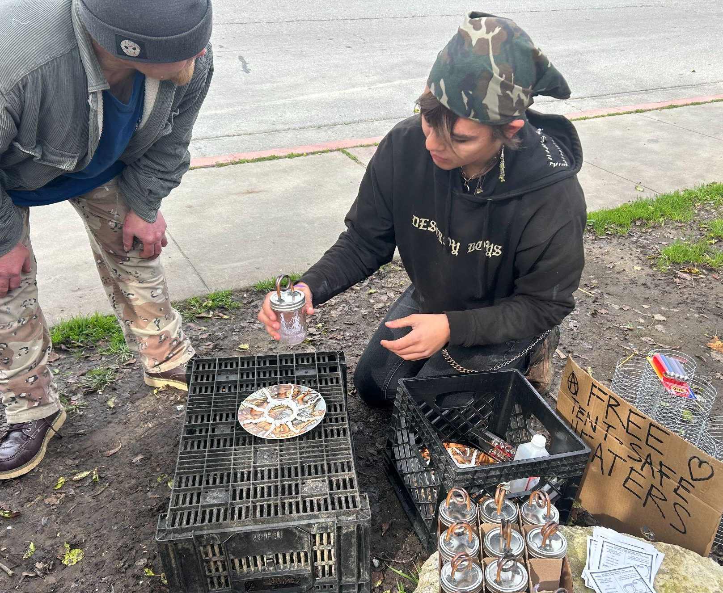
Calia and the Bread and Roses team

Check it out!
- “We Can Make it Out of Narrow Places”: Open Mic for Resilience and Collective Care- Bring your artistic, poetic, and musical creativity to share what brings you hope and joy. Friday, April 19, 11:30am. Downtown Clocktower.
- Are you part of a community or faith group interested in learning about the history of the Catholic Worker or our vision of the coming Bread and Roses Cafe? Let us know if you’d like to host us for an informative discussion!

Distributing homemade tent-safe heaters, and teaching how to use them safely.

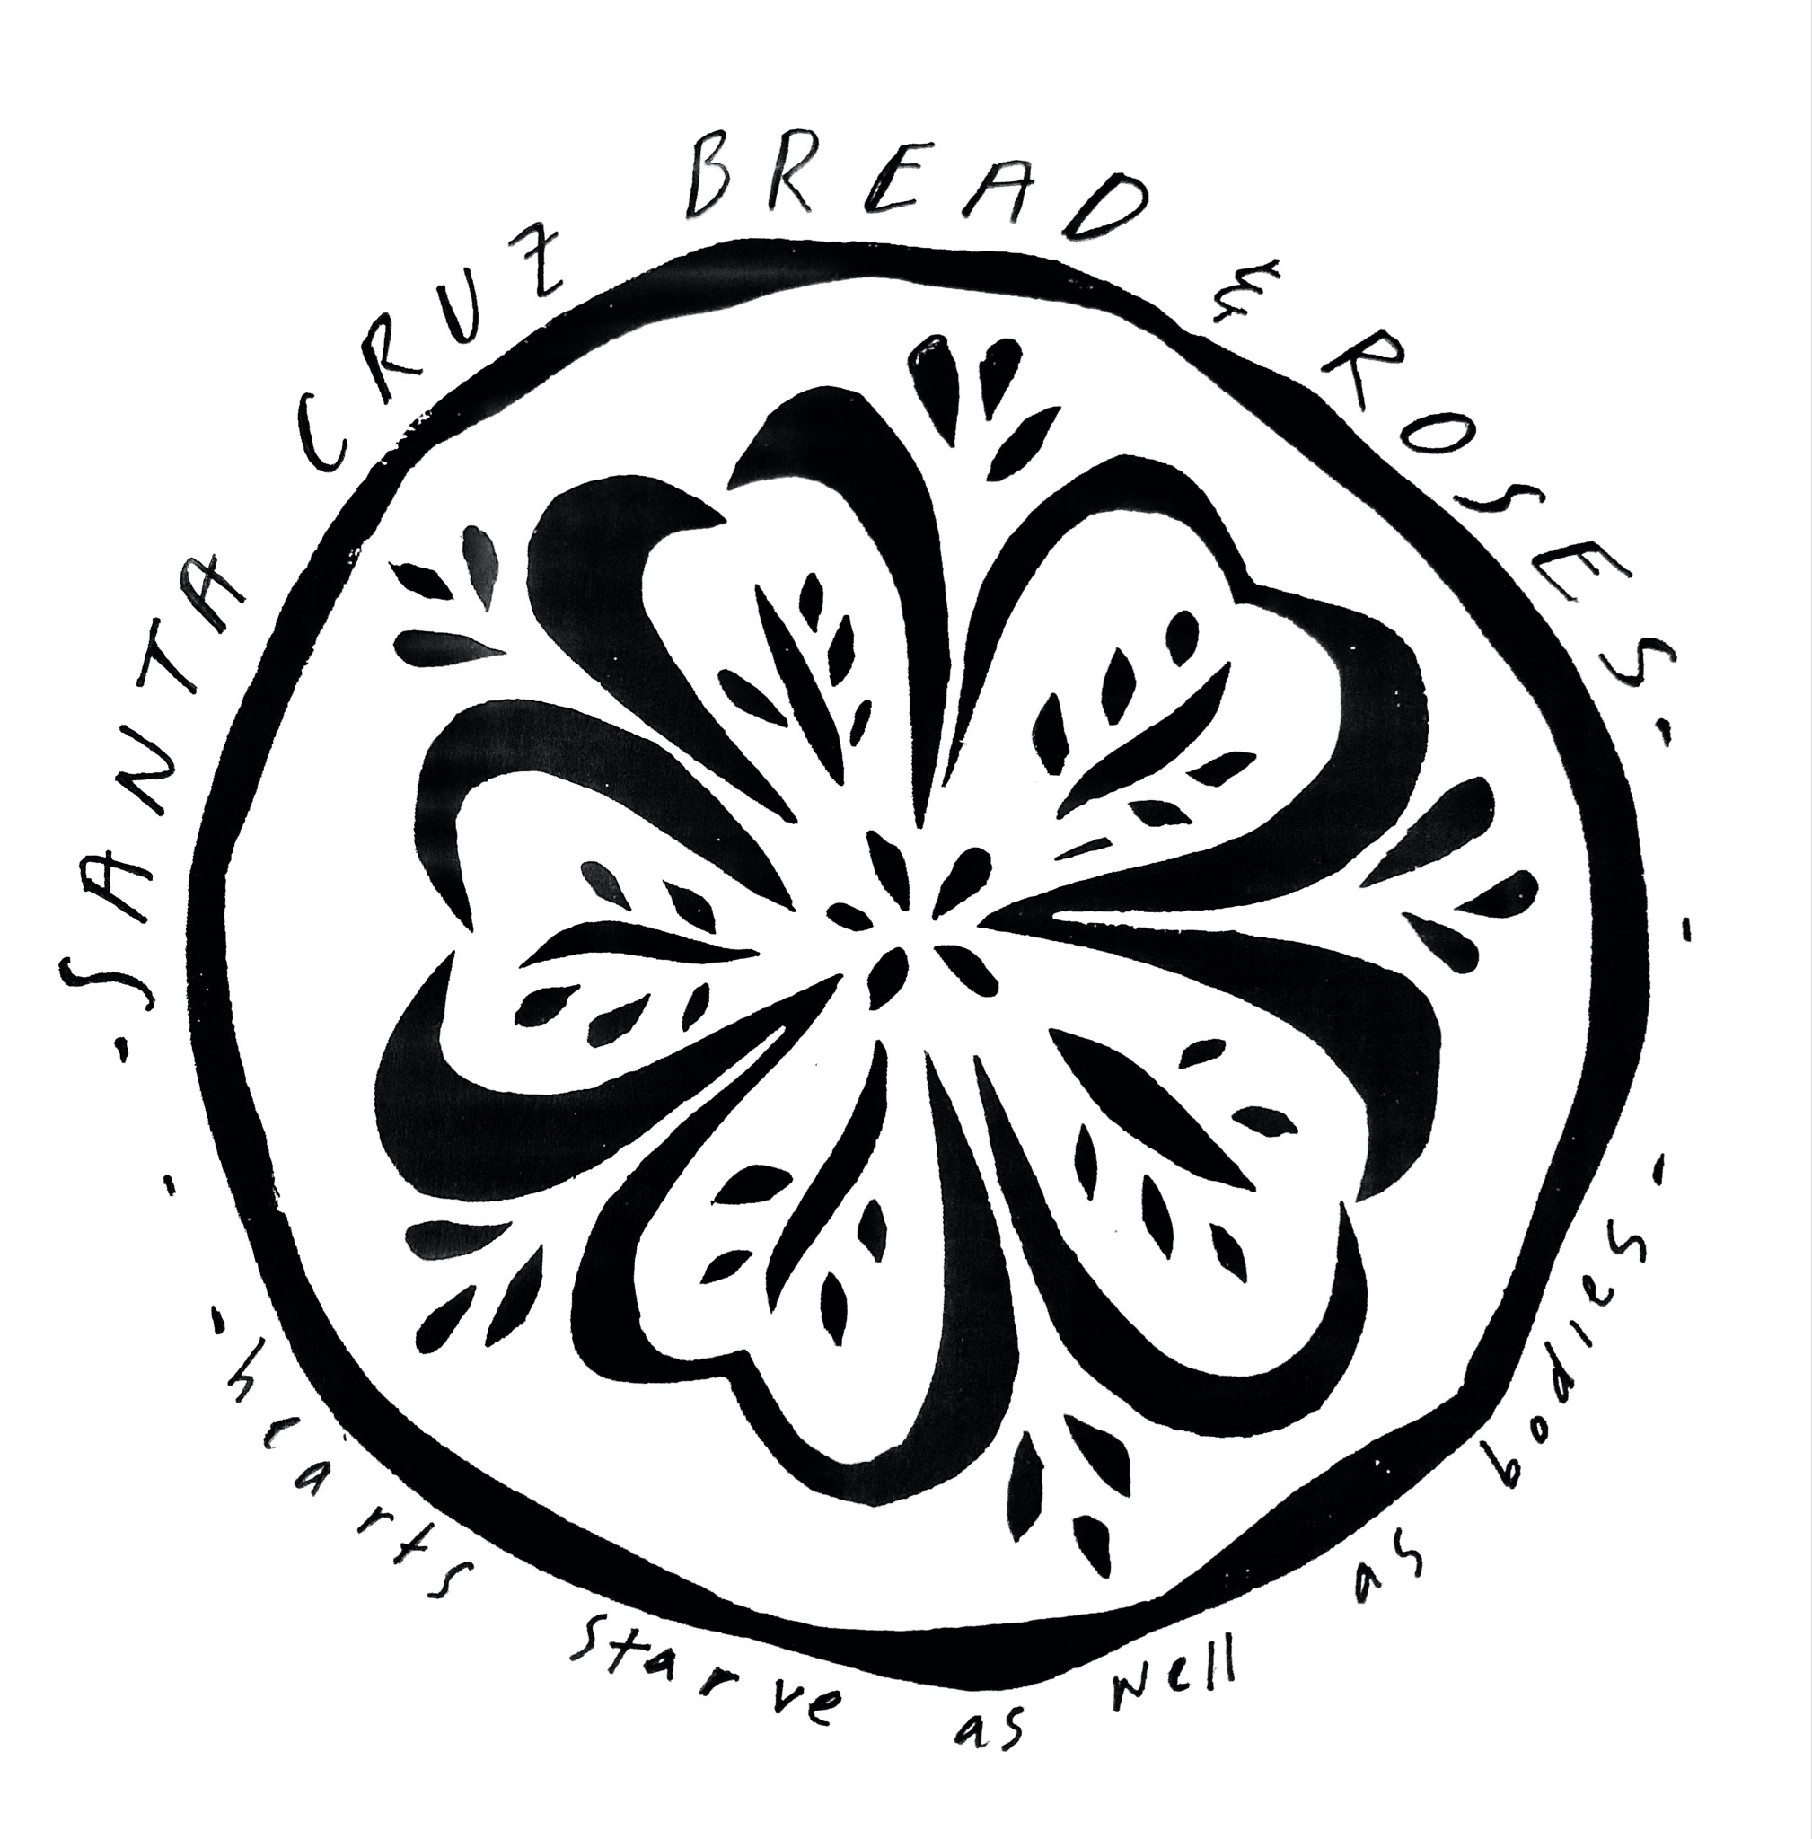

Santa Cruz Bread and Roses accompanies those experiencing homelessness and poverty in Santa Cruz by nourishing people’s basic physical needs with joy and dignity.
We serve breakfast and essential supplies for free on
local streets 3 times weekly.

What’s Happening?
- “We Can Make it Out of Narrow Places”: Open Mic for Resilience and Collective Care- Bring your artistic, poetic, and musical creativity to share in the theme. Friday, April 19, 11:30am. Downtown Clocktower.
- We’re in need of clean jackets, men’s pants, shirts, shoes, and blankets for distributions. Ask your friends and neighbors if they’ve got some to donate as well!
Can you make a monthly financial donation? Contribute to our current work and help fund the future Bread & Roses Cafe, a hub providing good food on a sliding-scale payment model, basic supplies, and a sense of belonging for all. Mail a check or use the link below: PO Box 2142 Santa Cruz CA 95063

